Garment Worker Center
Chemical Training Susan Hardwood

Welcome & Food
Time: 20 mins

Introduction
Time: 15 mins

Instructor: Thank everyone for attending. Have everyone introduce themselves. Introduction of the Garment Worker Center and importance of the training with the participants. Explain the icebreaker activity:

Activity: Garment Worker Bingo!
Time: 20 mins
Materials:
- Garment Worker Bingo Card (found at the end of this packet)
- Pen/Pencils

Instructor: Hand out a game card to each participant. Instruct participants fill out the questionnaire and be sure to ask if there is anyone who might need help reading/filling out the card, if so, assist as necessary. Ask participants to mingle and look for another person who shares the same/similar answers as them. Once they have found a match (Bingo!), have participants sign off on their similar answers with a signature.

For example: If you are a sewing operator, find someone within the group who is also a sewing operator and have them write their name next to your answer.

Once we’ve reached the maximum time allocated, get everyone back together for a brief group discussion and debrief. Once three or four folks have shared, move forward with the discussion part of the training.

Discussion
Time: 45 Minutes
Materials:
- Butcher Paper
- Markers
- Pens/Pencils

Instructor: Ask, What are Chemicals? Wait for folks to answer, write down participants replies.

Instructor can further clarify by stating that when we are referring chemicals we are referring to the chemical substances and chemical products (which can come in the form of solids, liquids, powders, vapors, gases, fibers, and smoke) we use at home, work, and in our day to day lives. These could range in the products we use to clean, paint, or even use on our body.

- Ask, What are some of the chemicals we use:
  - At home?
  - In our day to day lives?
  - At work?

Split the butcher paper into 3 (or more) categories. Ask folks to share while the instructor writes down all of the replies from the participants.

- Instructor:
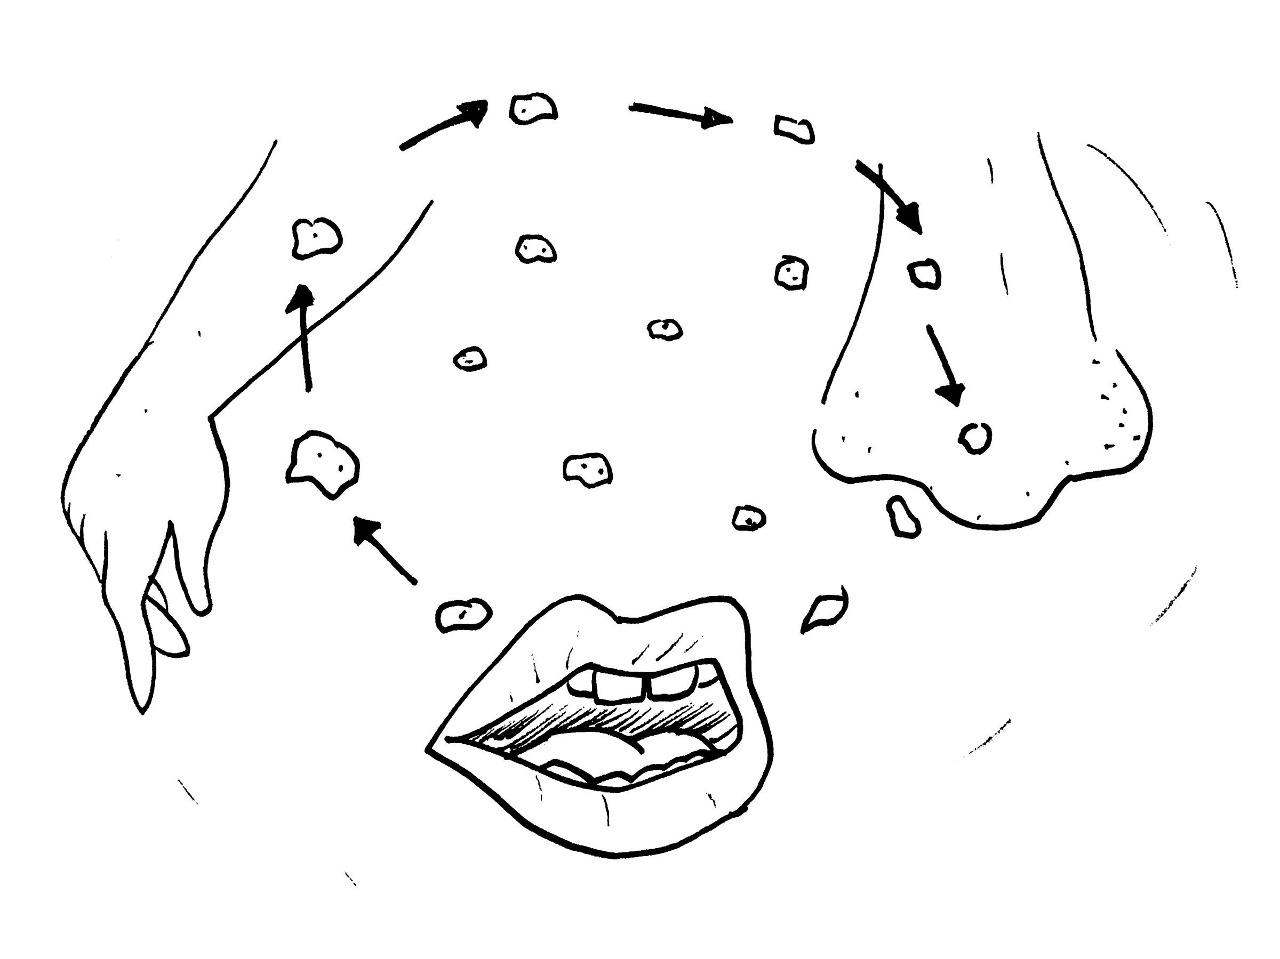
  - Ask, Do you think these chemicals affect our bodies? If so, how? As people are sharing their replies be sure to write down their responses.
  - Ask, How do these chemicals enter our body? Wait for folks to respond and write down their replies as they share.
    - If folks seem a little hesitant to engage, begin by providing some possible examples chemicals enter our body (not limited to):
      - Skin: Occurs when the substance or product comes into contact with with or skin. These substances or products can have physical short or long term effects on our skin.
        - What are some reactions this can have on our skin?
      - Mouth: Occurs when we ingest the substance or product through other food, drinks, cigarettes, on our facial hair or hands.
        - What are some reactions this can have in our mouths?
      - Nose: Occurs when we inhale the substance or product that are in the air.
        - What are some reactions this can have on our noses?
        - What are some reactions this can have on our internal organs?

  - Now that we have identified some chemicals and the different ways they enter the body, explain that the effects of the substances or products can have some short term or long term effects on our bodies. Define the terms “acute” and “chronic” in reference to the symptoms.
    - Acute: Abrupt, sharp, and brief. Often connotes an illness that is of short duration, rapidly progressive, and in need of urgent care.
    - Chronic: Lasting a long time. A chronic condition is one that lasts 3 months or more.
      - *Be sure to state that both definitions are in reference to medicine.
      - *If participants should ask, be sure to clarify that neither of the above definitions are mutually exclusive.
  - Ask, Has anyone in the room suffered from allergic reactions to chemicals? If participants need further explanation on allergic reactions explain what an allergic reaction is and how it occurs:
    - Allergic reactions are sensitivities to substances called allergens that come into contact with the skin, nose, eyes, respiratory tract, and gastrointestinal tract. They can be breathed into the lungs, swallowed, or injected.
    - What are some of the effects that the chemicals can cause to our health? Encourage folks to refer to the “acute” and “chronic” symptom definitions when giving examples and answers.

  - Introduce health hazard symbols (found at the end of the packet). Show the symbols then have folks try to verbally guess what they signify.
    - As participants are guessing the meanings, be sure to write responses you hear underneath the symbols.
    - Once participants have discussed and guessed, define and explain the meanings to each of the symbols presented:
        - Health Hazards
          - This symbol indicates that this substance or product poses a serious health hazard which can cause but is not limited to:
            - Carcinogen
            - Mutagenicity
            - Reproductive Toxicity
            - Respiratory Sensitizer
            - Target Organ Toxicity
            - Aspiration
        - Flame
          - This symbol indicates that is very likely that substance or product is flammable or poses a risk of causing but not limited to:
            - Flammables
            - Pyrophorics
            - Self-Heating
            - Emits Flammable Gas
            - Self-Reactives
            - Organic Peroxides
        - Exclamation Mark
          - This symbol indicates that this substance or product poses a serious health hazard which can cause but is not limited to:
            - Irritant (skin and eye)
            - Skin Sensitizer
            - Acute Toxicity (harmful)
            - Narcotic Effects
            - Respiratory Tract Irritant
            - Hazardous to Ozone Layer (Non-Mandatory)
        - Gas Cylinder
          - This symbol indicates that the substance or product gases under pressure, including compressed gases, liquefied gases, refrigerated liquefied gases, and dissolved gases.
            - Gases under pressure
        - Corrosion
          - This symbol indicates that the substance or product can cause but not limited to:
            - Skin/Corrosion/Burns
            - Eye Damage
            - Corrosive to Metals
        - Exploding Bomb
          - This symbol indicates that the substance or product poses the risk of exploding and can also cause but not limited to:
            - Self-Reactives
            - Organic Peroxides
        - Flame Over Circle
          - This symbol indicates that the substance or product can be oxidizing
        - Environment (Non-Mandatory)
          - This symbol indicates that the substance or product can be harmful to the environment.
            - Aquatic Toxicity
        - Skull and Crossbones
          - This symbol indicates that this substance or product may be fatal if a person comes into direct contact with it. Stress that point that while all chemicals may be deadly if the person is exposed for long periods of time, this symbol is only used when death is almost immediately or certain if a person were to come into contact with it.
            - Acute Toxicity (fatal or toxic)

Instructor: Conclude this portion of the training with a collective recap of the chemicals, terms, and symbols we have learned thus far.

BREAK (5 mins)

Instructor: Gather everyone back from the break to begin the next discussion.

Discussion
Time: 15 minutes
Materials:
- Butcher Paper
- Markers

Instructor: Start the dialogue by referring back to their Garment Worker Bingo playing cards as well as workplace chemical substances or products that folks have already identified. Ask participants about some of the most common chemicals they use at work (ask if they would like to add to the list). Again, try to encourage participants to engage by asking question such as:

- Do you use any sprays at work?
- Do you use any oils at work?
- Do you think the fabric has chemicals? If so, how have they affected you (if ever).
- Do you think the dust/fabric that is in the air has chemicals? If so, how have they affected you (if ever).
- Have your eyes, throat, hands, nose, etc. ever been irritated? Can we attribute these to chemicals used at work?

As people begin sharing, write down the common problems that participants share. After participants have shared and identified collectively the top 3-5 common problems, begin the conversation around prevention and protection.

Prevention and Protection
Time: 30 minutes

Instructor: While referring to workplace chemical substances or products that they have already identified, Ask participants :
- What measures can we take, as workers, to reduce our risk and exposure to these chemical products or substances? Wait for participants to answer then follow with suggestions (For the purpose of the following activities be sure to state that we are starting off the suggestions from the easiest steps to the some of the concrete steps we can take we can take to ensure our safety):

  - 1. Protect yourself

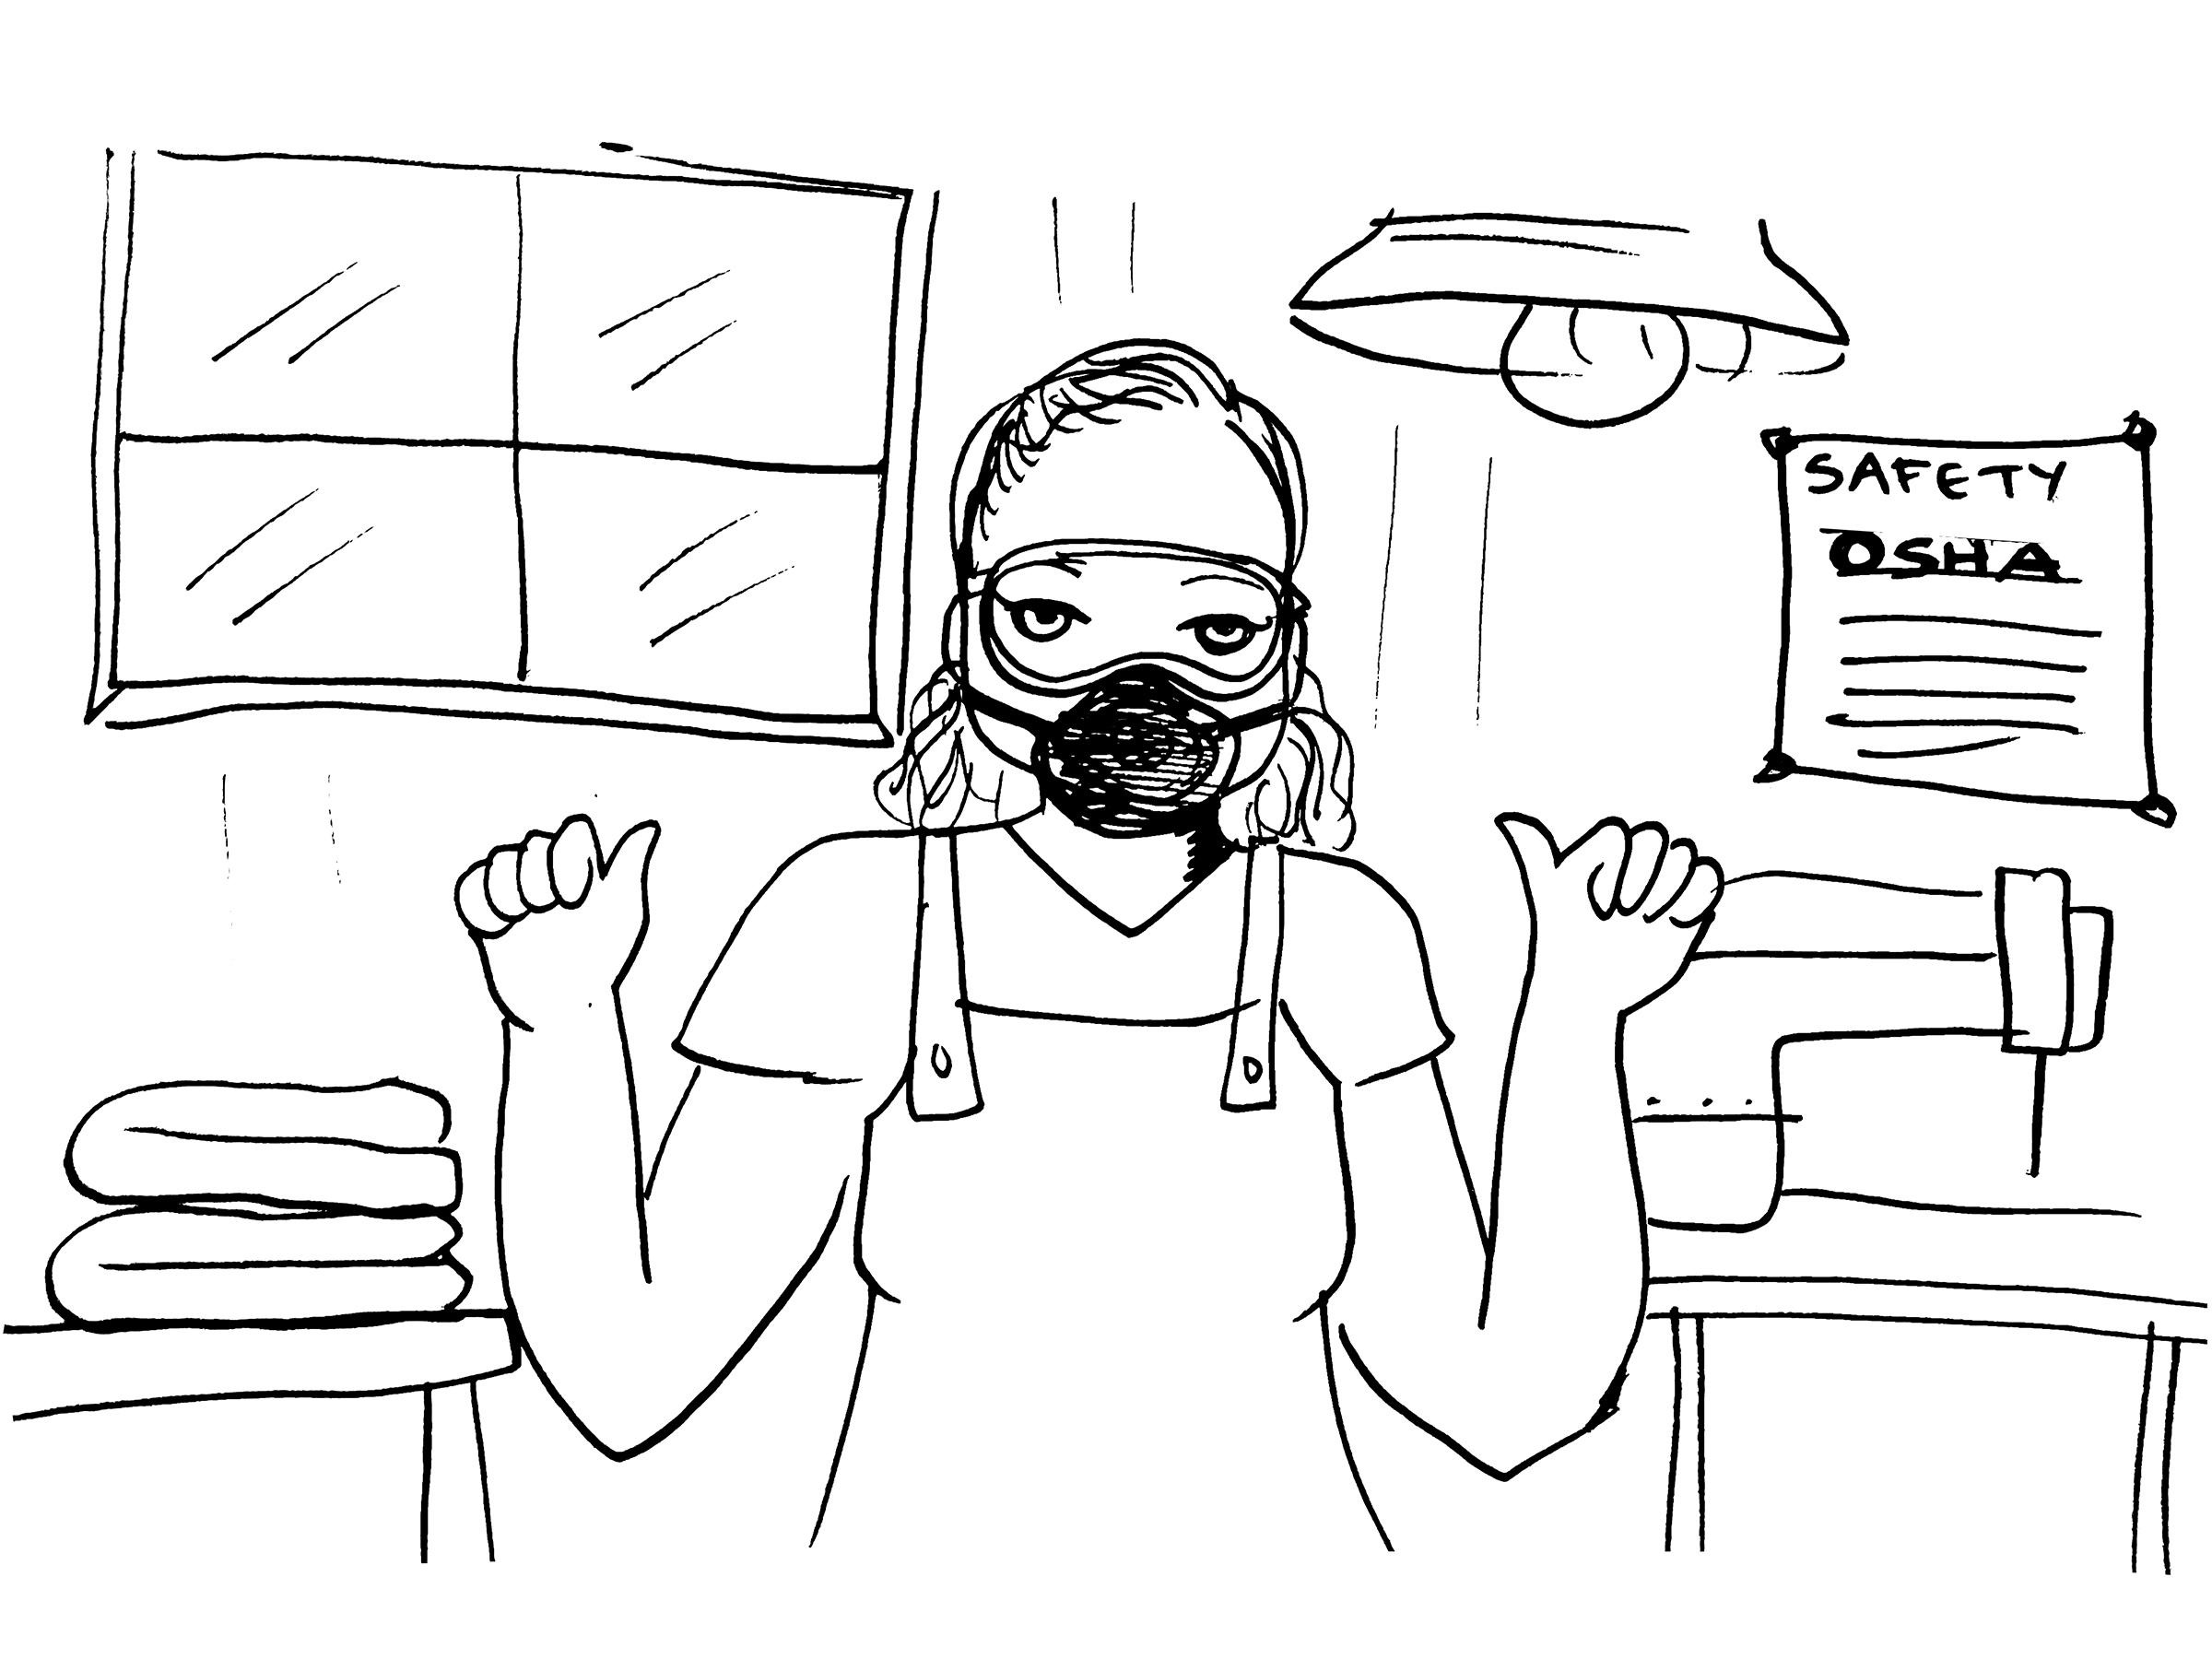
    - Use protective gear if you absolutely need to use chemical substances or products
      - Use protective equipment such as gloves, masks, aprons/protective clothing to protect your body against the chemical substances or products

  - 2. Changes in the way we work
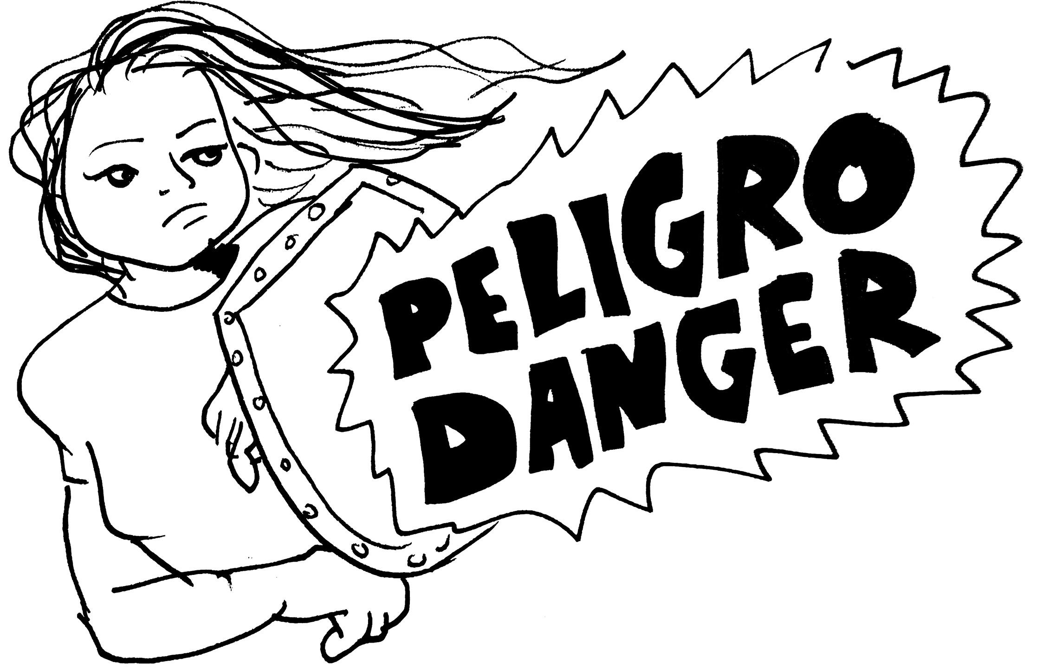
    - Try to clean your work area regularly to reduce dust and chemicals in the air.
    - Keep your drinkable liquids and/or food away from the chemical substances or products.
    - Use the tools provided to protect against chemical substances or products in the workplace
    - Cover or store the containers when they are not in use.
  - 3. Advocate for Workplace Changes
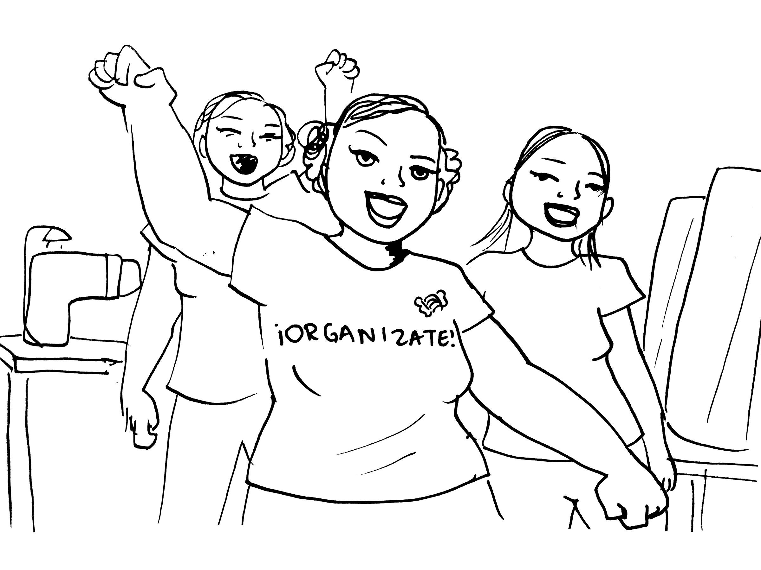
    - Advocate for more time to wash your hands frequently.
    - Advocate to use less chemical substances or products as possible.
    - Try to reduce the amount of chemical substances or products that are in the air
    - Good ventilation is key to reducing chemical substances or products in the air, if possible try to reduce the use of sprays or powders

  - 4. Have a Health and Safety Plan in case of emergencies:
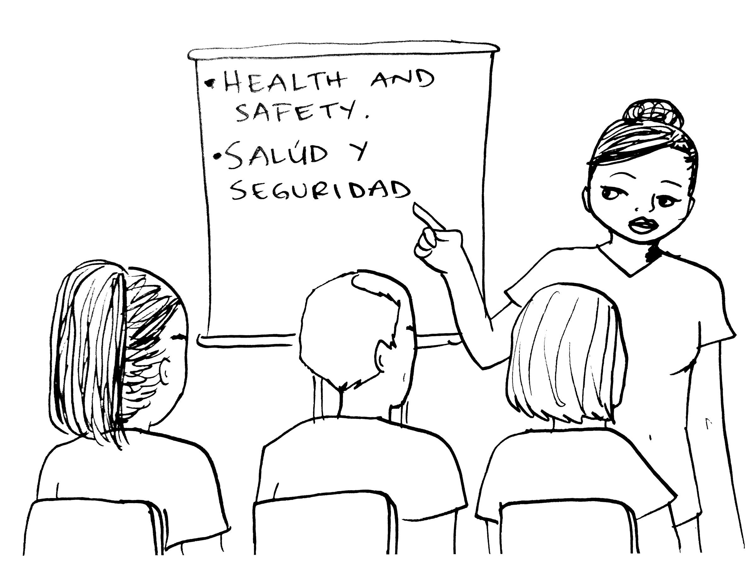
    - Form Health and Safety Committees
      - It is every worker's right to form a health and safety committee within their workplace to address unsafe working conditions and prepare for emergencies.
      - Identify point people within the factory with important roles which can help identify the:
        - Boss
        - Manager
        - Supervisor
        - Emergency contacts
  - 5. Eliminate the risk completely:
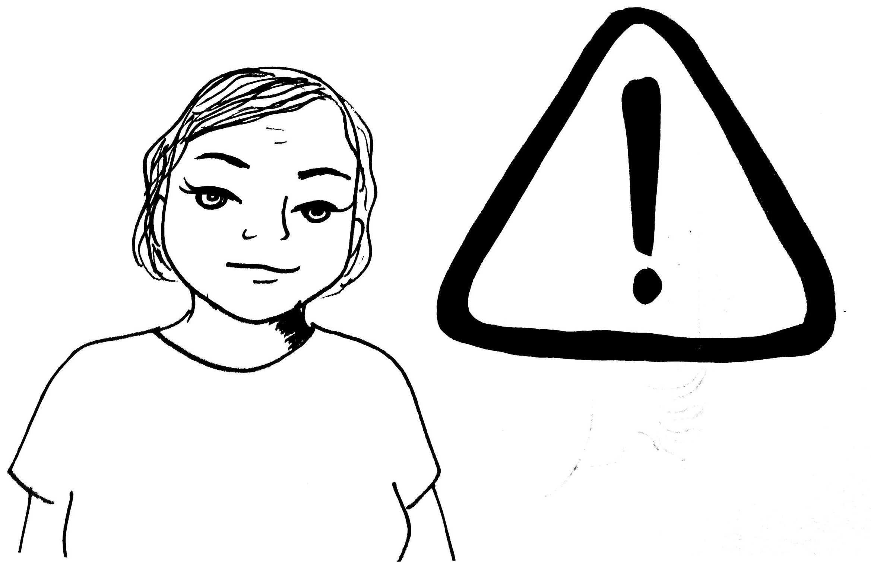
    - Keep all chemical substances or products stored in a designated location where it is not within people’s reach.
    - Replace or avoid the hazardous chemicals all together, ideally.

Instructor: Ask participants if they are familiar with the agencies in place to aid workers regarding health and safety violations. Wait for replies, then go over OSHA and CAL-OSHA information and differences. State disclaimer between federal and state agencies as some laws and regulations differ from state to state.

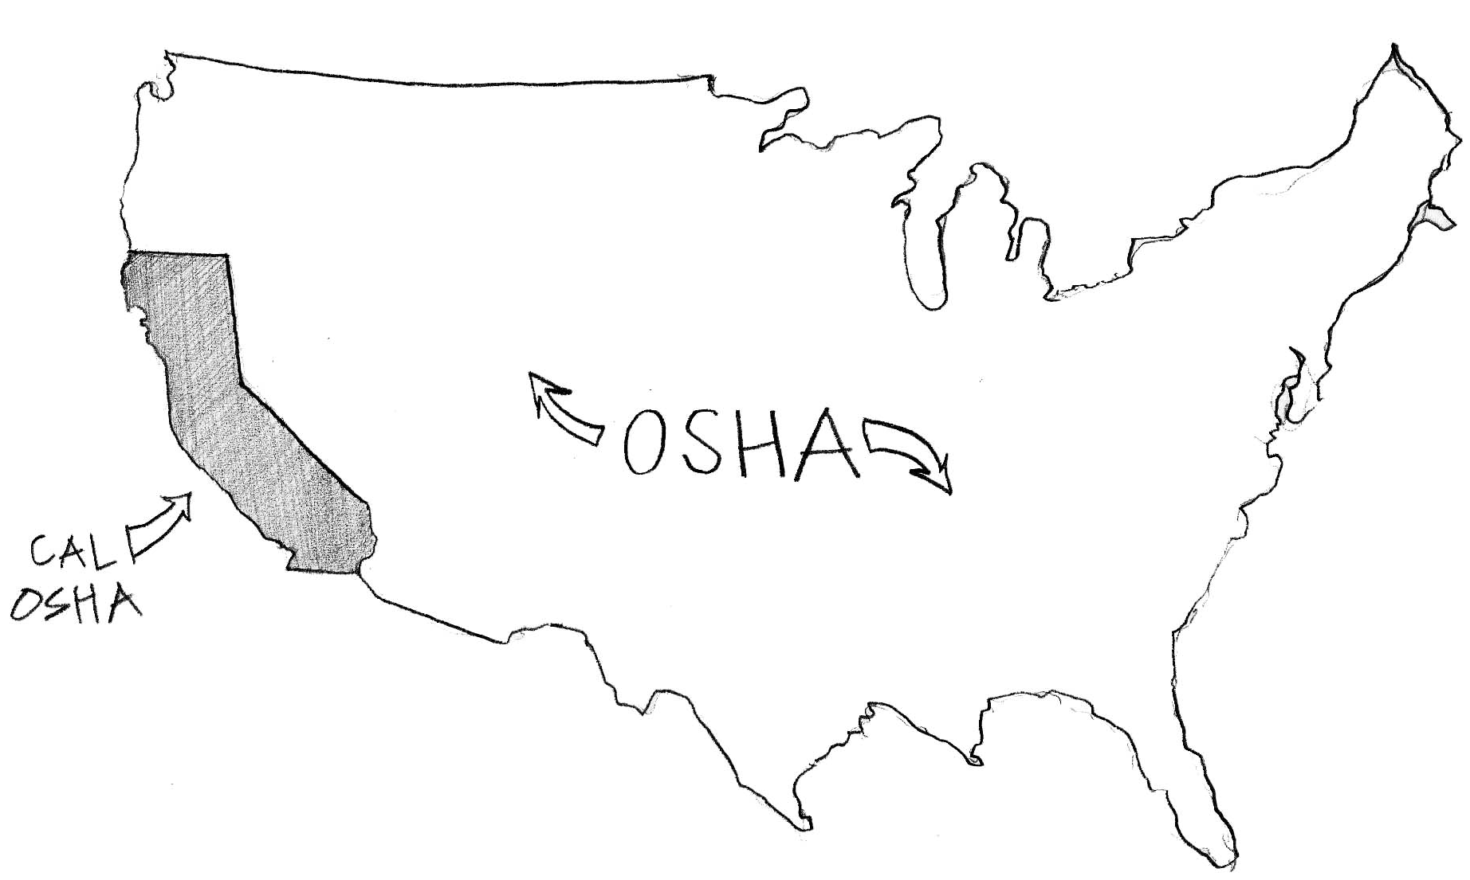

The Occupational Safety and Health Administration (OSHA) is an agency of the United States Department of Labor. Congress established the agency under the Occupational Safety and Health Act. This agency is in place to aid workers on a federal level.

In California we also have a version of OSHA which focuses more on California specific rules and regulations. Here, every employer has a legal obligation to provide and maintain a safe and healthful workplace for employees, according to the California Occupational Safety and Health Act of 1973.

Since the use of chemicals is common within the garment industry, employers and workers must take measure to prevent workplace injuries.

The responsibility of the employer: As of 1991, a written, effective Injury and Illness Prevention (IIP), Program is required for every California employer and should be accessible to all employees.

What should an IIPP include?
- Responsibility
  - For example: The name, title and contact information for the person(s) that has overall responsibility should an emergency occur.
- Compliance
  - For example: What disciplinary process does the employer follow when issues are brought to their attention?
- Communication
  - For example: How does the employer or job encourage employees to anonymously notify management of safety and health concerns without fear of reprisal
- Hazard Assessment
  - For example: The name of the person(s) conducting periodic inspections to identify and evaluate workplace hazards
- Accident/Exposure Investigation
  - For example: The name of the person(s) conducting investigations of our workplace injuries, illnesses and accidents, hazardous substance exposures and near-misses
- Hazard Correction
  - For example: Step by step plans on how to resolve hazardous violations
- Training and Instruction
  - For example: Guide on how the employer and/or job trains and instructs their workers
- Recordkeeping
  - For example: Organization that have ten or more employees and keeps records of scheduled and periodic inspections meeting the full record keeping requirements of T8CCR 3203(7)(b)(1).

Instructor: With the help of the participants, conclude this portion of the training with a collective recap of the chemicals, terms, and agencies we have learned thus far.

Activity: Playing with Danger (Adapted from a Hesperian Health Guides and Garment Worker Center chemical training collaboration).
Time: 30 Minutes

Instructors: This card game is an opportunity for participants to put into practice what they’ve learned through this training. Before starting the activity, explain the point system regarding the “Solutions” to demonstrate that the easiest solutions, like wearing protective equipment, are only worth one point because they are the least likely to fully protect against harm; while the most difficult ones, such as replacing or removing all chemical substances or products all together are worth four points because they are the ones that would likely protect the worker more.

The objective of this game is to identify the chemical dangers according to the risks they pose upon entering our bodies through the skin, eyes, nose, mouth. Participants must work together as a team in order to come up with enough points to solve the dangers of the game.

Rules: The participants must explain why they played the “Solution” card that they did to the rest of the players, the other players then will have a say as to whether they find the card and reasoning for the card acceptable or not. If a player feel that they do not have a good card to play, the player may opt to skip.

How to play:
- Each team will play against the “house” (instructor/facilitator) who will be representing the boss.
- Put all of the cards labeled “Danger” facedown in the middle of the table. Put all of the cards labeled “Realities” facedown in the middle of the table as well. Deal five cards labeled “Solutions” to all participants, face down so that the other participants don’t see.
- To start the game, a participant turns over one of the cards labeled “Danger” and is placed adjacent to the other cards. The group will read it together.
- Each player then looks at their cards and decides which “Solution” they will play, choosing the most relevant, like the one which has the most points; however, the card worth four points cannot be used until the team has formed a union (see rules).
- In order to play a card, the player must explain why this “Solution” would work. The player should place the card face up on the table for the other players to see.
- When all players have played a card on the table and others have agreed on their reasoning, the “House” adds up all the points between all the cards played.
- After all points have been added, we turn a “Realities” card over and we add or subtract the points that are on the “Realities” card from the team's total sum.
- If the total sum of the participants still adds up to eight points total, after adding or subtracting the points from the “Realities”, the beat the boss. If not, they lose to the boss.
- The game ends when the teams have won five rounds.

The “Solutions” cards worth four points cannot be played until the team forms a union. A union is formed once the team has won three rounds (they don’t have to be consecutive wins).

The Cards:
- Danger: Each card has the description of a chemical hazard at the workplace, according to the means of exposure (ex: if the chemical enters the body through the mouth, eyes, skin, nose, etc.). These cards are put at the center, turned face side down, and are turned over only once we start a new round.
- Solutions: At the beginning of the game, each participant receives 4 cards, which are distributed face side down. The card that is worth four points cannot be played until the group forms a union (see rules). The “Solutions” cards have points from one to four. The cards worth one point are only personal protection, the cards worth two points are workplace changes, the cards worth three points are changes in the administration of the workplace, and the ones that are worth four are the stronger ones, where we eliminate the risks completely.
- Realities: These cards include a variety of situations that affect our workplace lives in positive or negative ways.

Evaluation

Activity: Roses and Thorns
Time: 15 Minutes
Materials:
- Butcher Paper
- Markers

Instructor: Split the butcher paper into two columns, label one “Roses” and the other “Thorns”. Explain to participants that everyone will get a chance to state one or more “Roses”- things that they really enjoyed about the training which can range from activities to information shared, as well as “Thorns”-things the participants felt the trainers or the training itself could improve on which can range from activities or topics discussed. Encourage all folks to share at least one “Roses” and one “Thorns”.

Be sure to type up the notes to reflect and improve the future trainings.

Disclaimer:

This material was produced under grant number SH-29641-16-60-F6 SH5 from the Occupational Safety and Health Administration, U.S. Department of Labor. It does not necessarily reflect the views of policies of the U.S. Department of Labor, nor does mention of trade names, commercial products, or organizations imply endorsement by the U.S. Government.

Training materials developed with grant funds will be posted at:
http://www.osha.gov/dtle/library

