Heat Illness Prevention and Protection

Welcome & Food
Time: 15 mins

Instructor: Welcome everyone and thank the participants for attending. Introduce yourself and have everyone else introduce themselves as well. Introduce the Garment Worker Center (mission and vision). Go over the agenda with the participants to let them know the topics that will be covered, Heat Illness Prevention and Protection.

Ice Breaker: Turn up the Heat (Sube la temperatura)
Time: 15 mins
Materials: Bowl, Temperature slips, computer (music)

Instructor: Tell participants that the bowl contains different heat/weather temperatures (ex: 60°F, 75°F, 95°F, etc…) Participants will pass a bowl around and when the music stops the participant who is holding the bowl will choose a temperature out of the bo and will have to act it out. The other participants will then guess the temperature according to the person’s actions. Once a participant guesses the correct temperature, the game continues for 3-4 rounds.

Heat inside the garment factories
Time: 20 mins
Materials: Butcher Paper, Markers, Computer

Instructor ask: Who is familiar with the term “Sweatshops”? Wait and write down the participant’s responses.

The term “sweatshop” can be traced back to the early 1800’s, originating from the textile industry where it was (and still is) used to describe working places (factories/warehouses) that had (have) poor working conditions, coupled with worker exploitation. Although there are many factors that make up sweatshops, one of the most obvious and dangerous ones is the excessive heat that these sweatshops emit without anyone taking proper measures to fix. If we break down the word further, in a literal sense it means a workplace/store where one sweats.

Instructor ask: Is this something common within the factory you work at? Wait and write down the participant’s responses. If participants feel comfortable, have them share examples of the conditions that they work in if they share similarities with the the term “sweatshop”.

Sweatshops still exist in Los Angeles
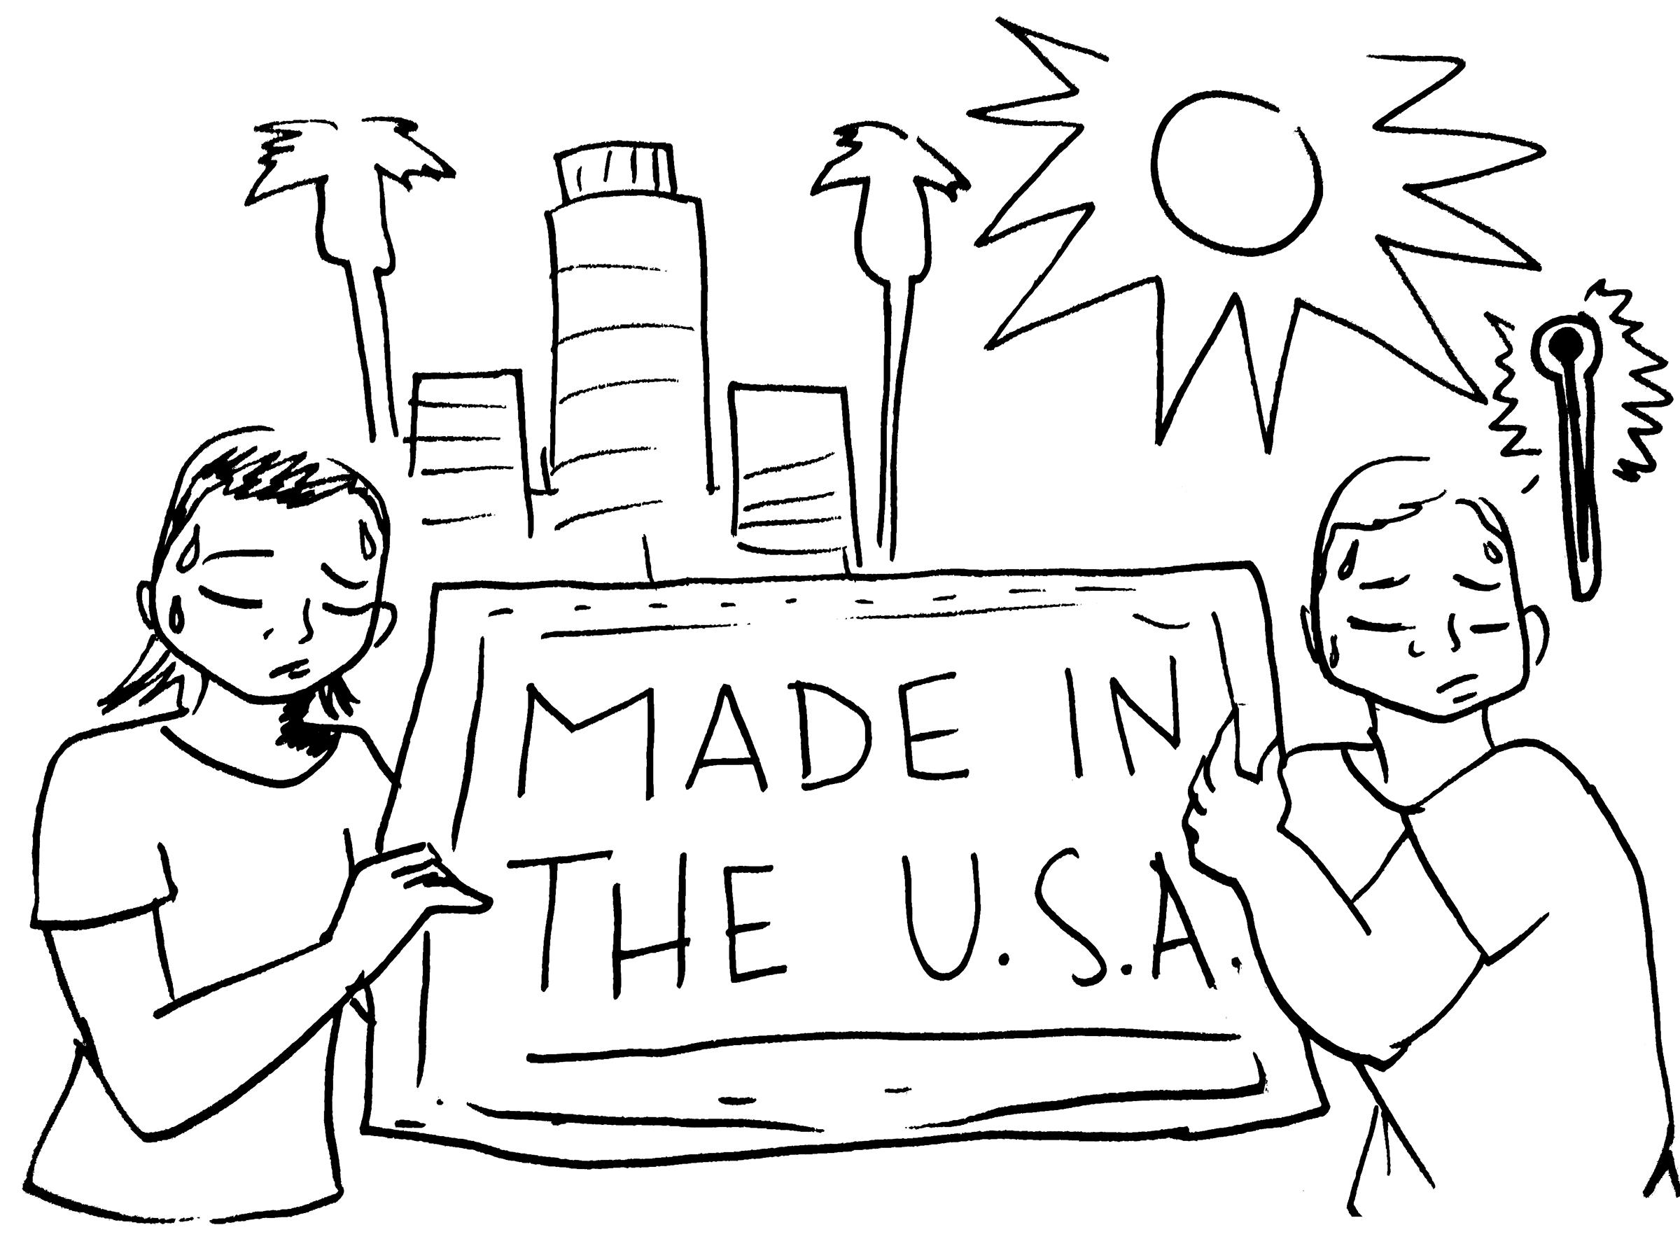
Almost 200 years later and the term sweatshop still applies to many of our working conditions and workplaces. Although this is the reality for most workers that still work within the garment and textile industry it doesn’t mean that it is acceptable. All workers have the right to a healthy and safe work environment. Under California Law, every employer has a legal obligation to provide and maintain a safe and healthy workplace for employees, according to the California Occupational Safety and Health Act of 1973.

Instructor: Inform participants that we will be will be going into detail regarding one of the main factors of sweatshops: Indoor heat.

Due to a recent drought in California, many cities, including Los Angeles, have experienced record breaking heat waves where temperatures have gone over 100 degrees fahrenheit for a few days at a time over the summer. This drought can be attributed to the ongoing climate change, which notably intensifies over the summer. These climate factors affect us both outside and inside our workplaces. The heat and humidity in the air, coupled with the machinery we use create a perfect recipe for potential heat illness inside the factories.

Taking a closer look at Heat Illness
Time: 25 mins
Materials: Butcher Paper, Markers, Computer, UCLA LOSH Handouts

Instructor ask: What do you think are some of the causes of indoor heat? Wait for replies and write them down on butcher paper as participants respond.

It’s important to understand how workplace, climate, and personal factors can affect and contribute to heat illness so that we can better identify and protect ourselves and our fellow co-workers. The following are a few of the sources that we should be mindful of if we work indoors:

- Workplace Factors (ppt)
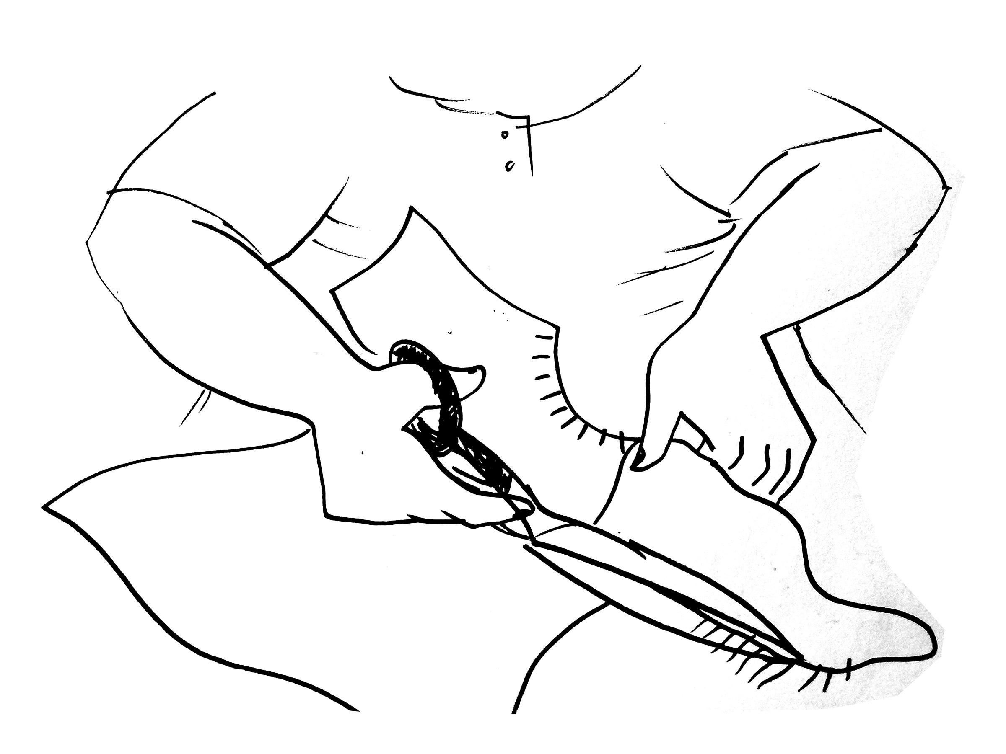
  - No adequate ventilation systems (no air conditioner, no windows, or fans)
    - Affecting the temperature in our working environment by trapping hot air inside the factories
  - Lack of potable water
    - Our bodies are made up of 50-75% of water. It is important that we take extra precaution during the summertime to keep our bodies hydrated. Lack of potable water can further dehydrate us during heat waves.
  - No rest breaks
    - Not giving workers time to cool down, use the restroom, drink water etc.
  - Lack of worker acclimatization
    - “Acclimatization”- letting the body adapt to the high/low temperatures.
  - Repetitive movements at work
    - The friction that our bodies creates adds to the heat inside the factory
  - Lack of health and safety training
    - Lack of training can be detrimental to a workplace because workers might not be versed in best practices to reduce heat in the workplace. Further, every workplace should have health and safety trainings regularly to be able to have action plans in place when a workplace emergency happens.
  - Heat from machinery at work
    - Also known as “radiant heat” adds to the heat emitted by the hot weather

- Climate Factors
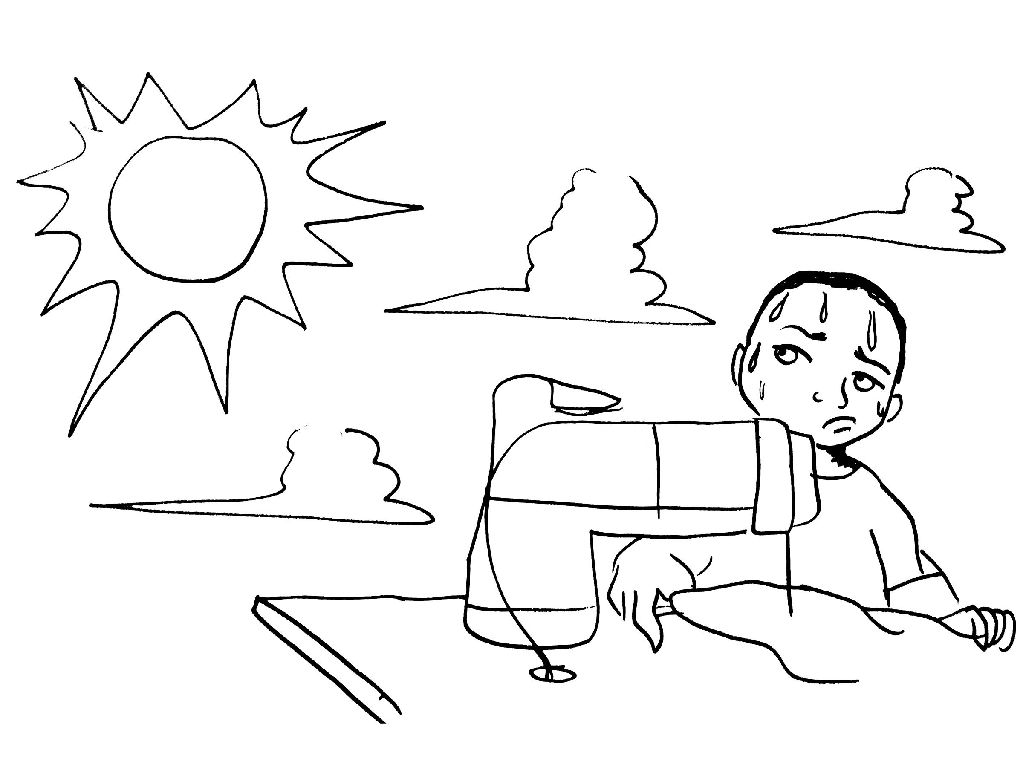
  - High temperatures
    - Due to climate change, the temperatures outside have increasingly began to rise
  - Humidity in the air
    - The heat index, also known as the apparent temperature, is what the temperature feels like to the human body when relative humidity is combined with the air temperature.
  - Lack of adequate air flow
    - If there is no air circulation it makes it harder for a factory to cool downl because the hot air doesn’t have any outlet, creating something similar to a heat bubble.

- Individual Factors
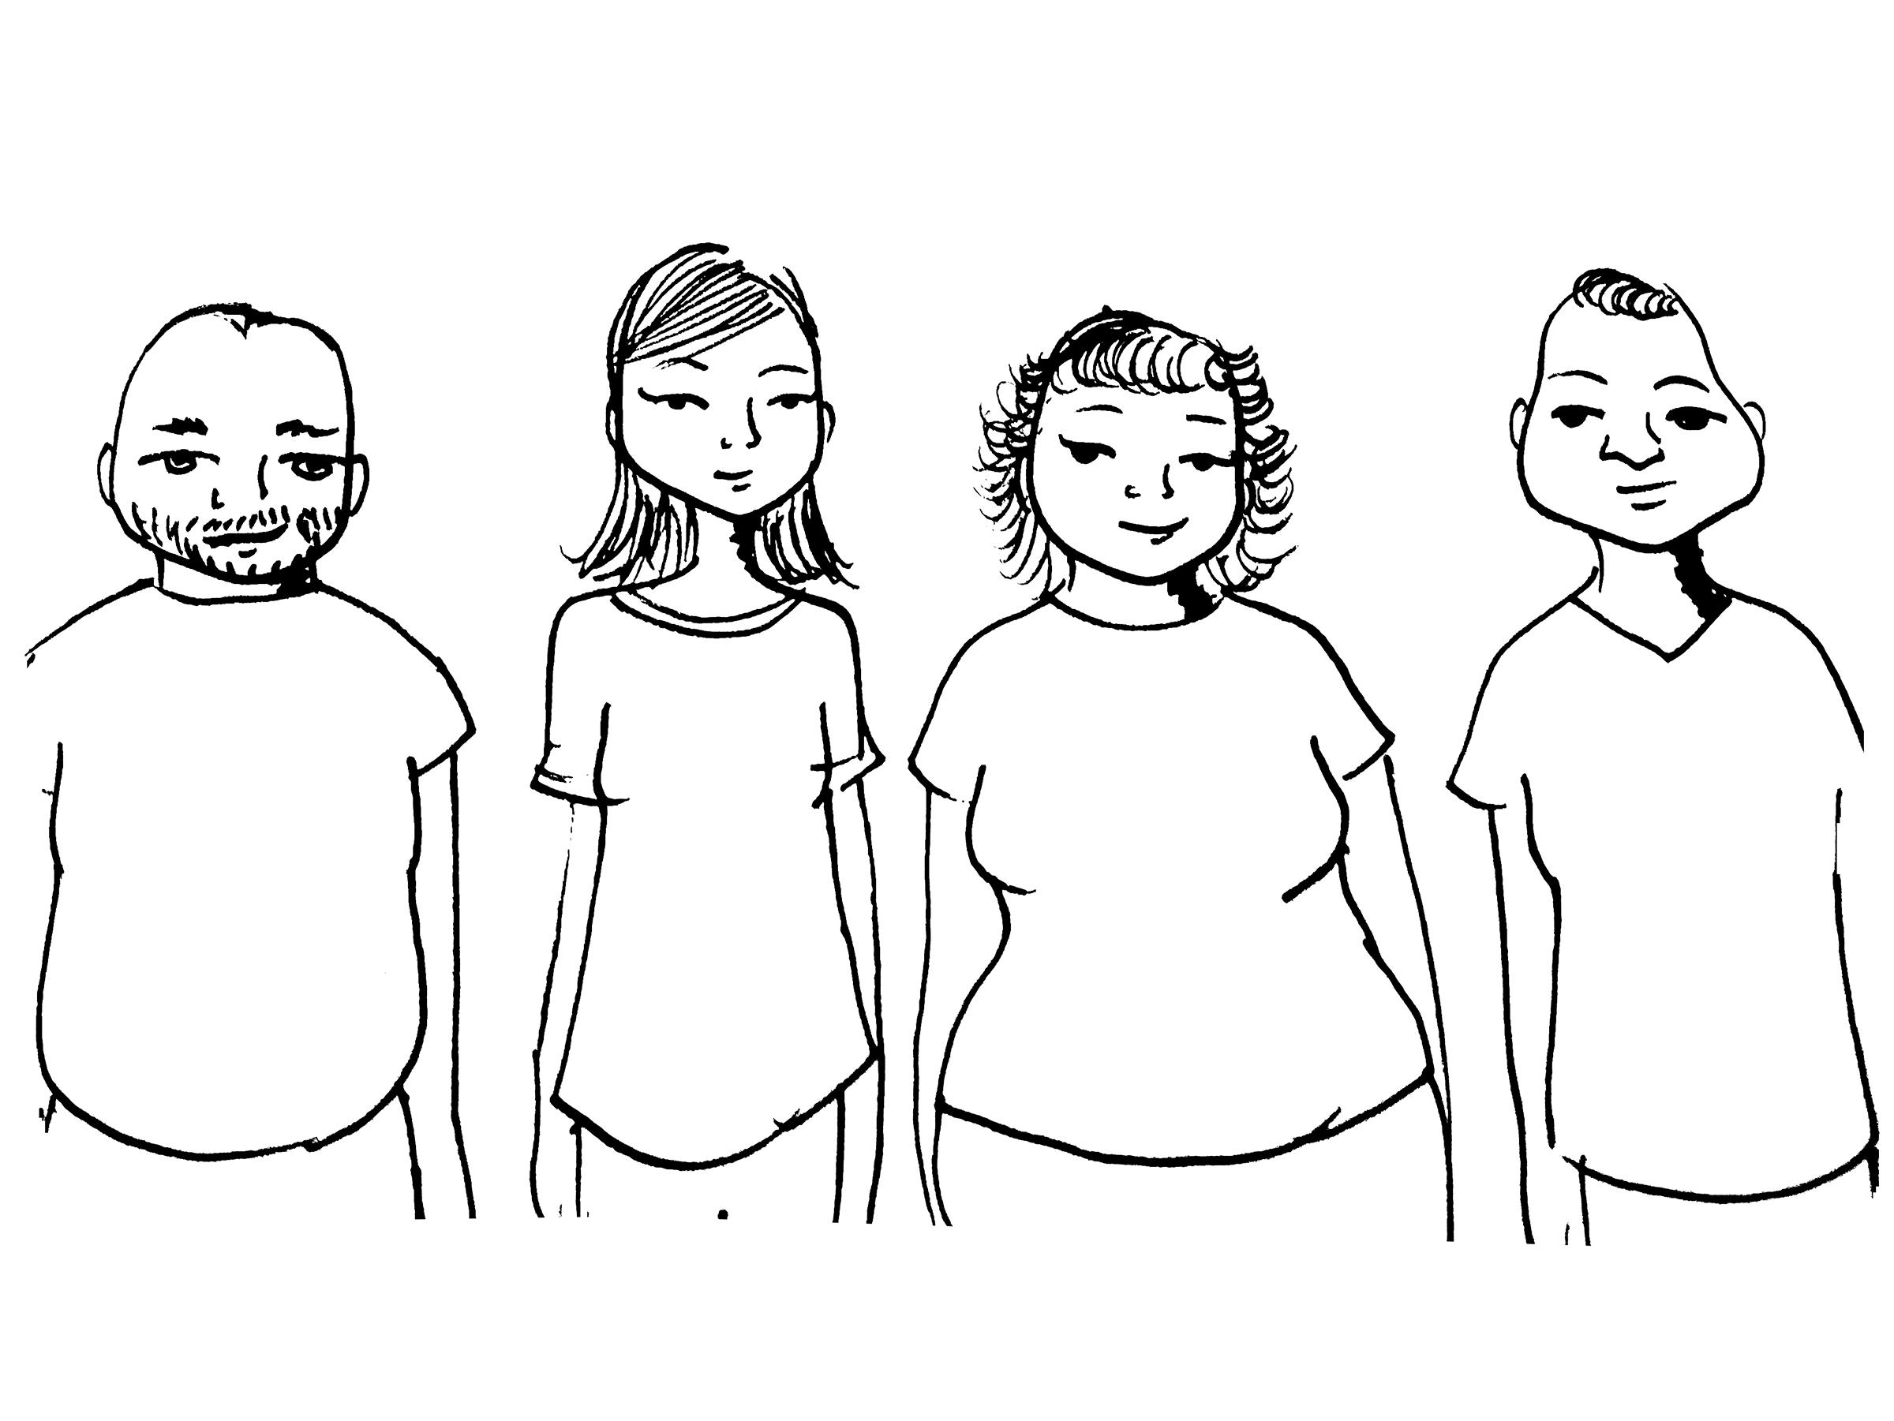
  - Dehydration
    - Our bodies are made up of approximately 50-70% water. Water is life and we need it to survive.
  - Preexisting medical conditions
    - Heat affects people who might be sick, have diabetes, or other health complications since their bodies might have to work harder to cool down.
  - Age
    - High risk:
      - Children- Developing bodies
      - Elderly- Aging bodies
  - Weight
    - Our body mass can also contribute to heat illness. This can be because it might take a body longer to cool down.
  - Physical Health
    - Our physical health is important because, it might take a body that is not as physically fit to take longer to cool down.
  - Alcohol or drug consumption
    - Alcohol and drugs sometimes alter the way our bodies to react to a lot of things, including heat. Some drugs and alcohol dehydrate the body further during a heat wave.
  - Type of clothing worn
    - Heavy and/or dark clothing tends to harbor more heat than light clothing

Preventing and Protecting ourselves from Heat Illness
Time: 15 mins
Materials: Butcher Paper, Markers, Computer

While there are things that are simply out of our control, there are measures we can take to ensure that we are protecting ourselves from heat illness which, left unattended, can lead to serious health effects including death. No two bodies react the same to heat. Although the symptoms of heat illness can be similar, we must always take into consideration that these symptoms might affect everyone differently. When our bodies go into heat distress, our survival/defense mechanisms will start giving us warning signs that might manifest in the following ways:

- Be on the alert if you start to experience the following:
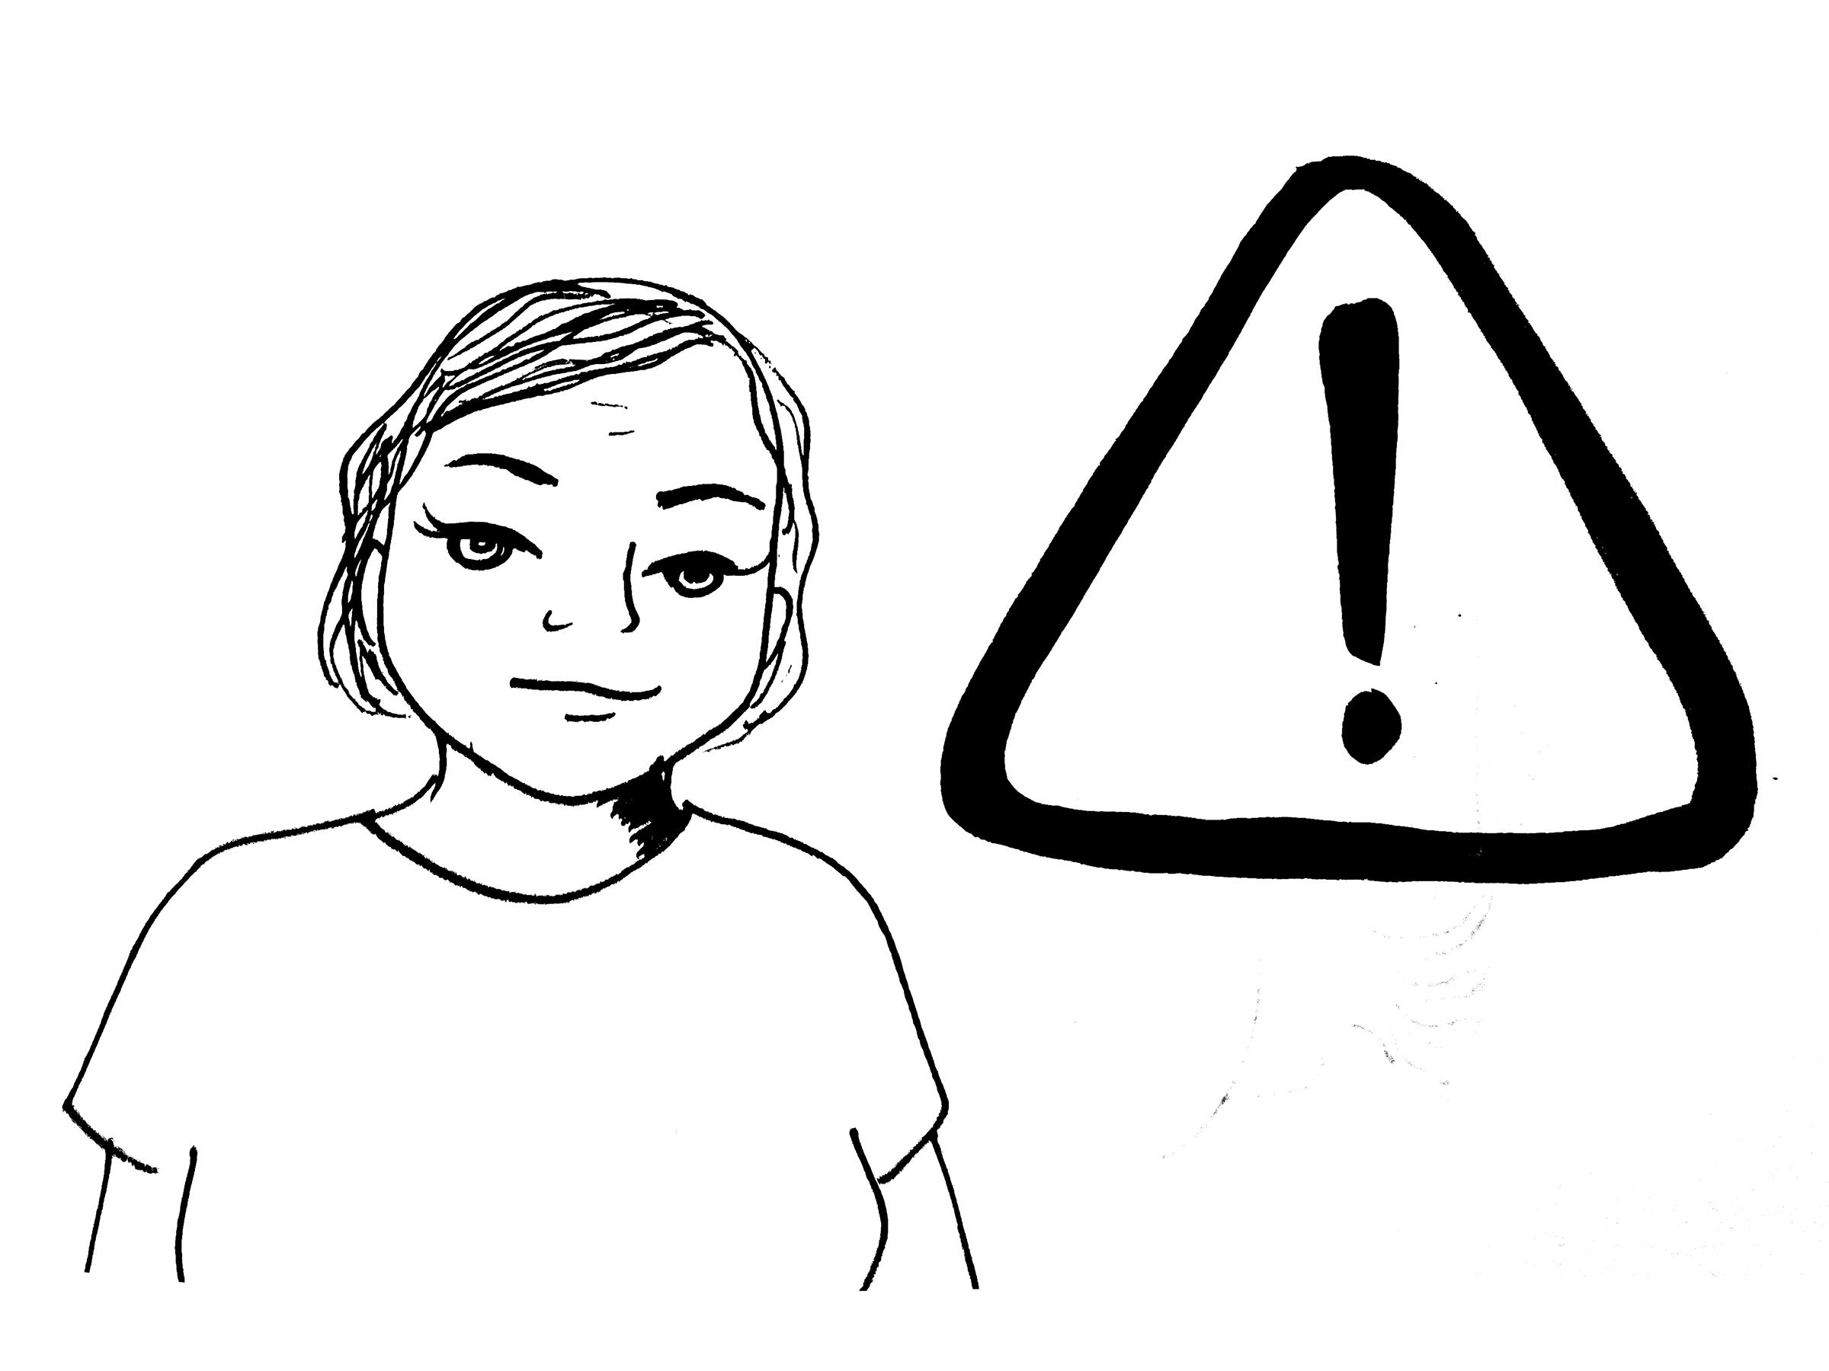
  - Sweat
  - Fatigue
  - Irritability
  - Heat rash
  - Cramps

- Take special precautions when you start to experience the following:

  - Nausea
  - Dizziness
  - Short of Breath
  - Headaches

- Seek help when you start to experience the following:

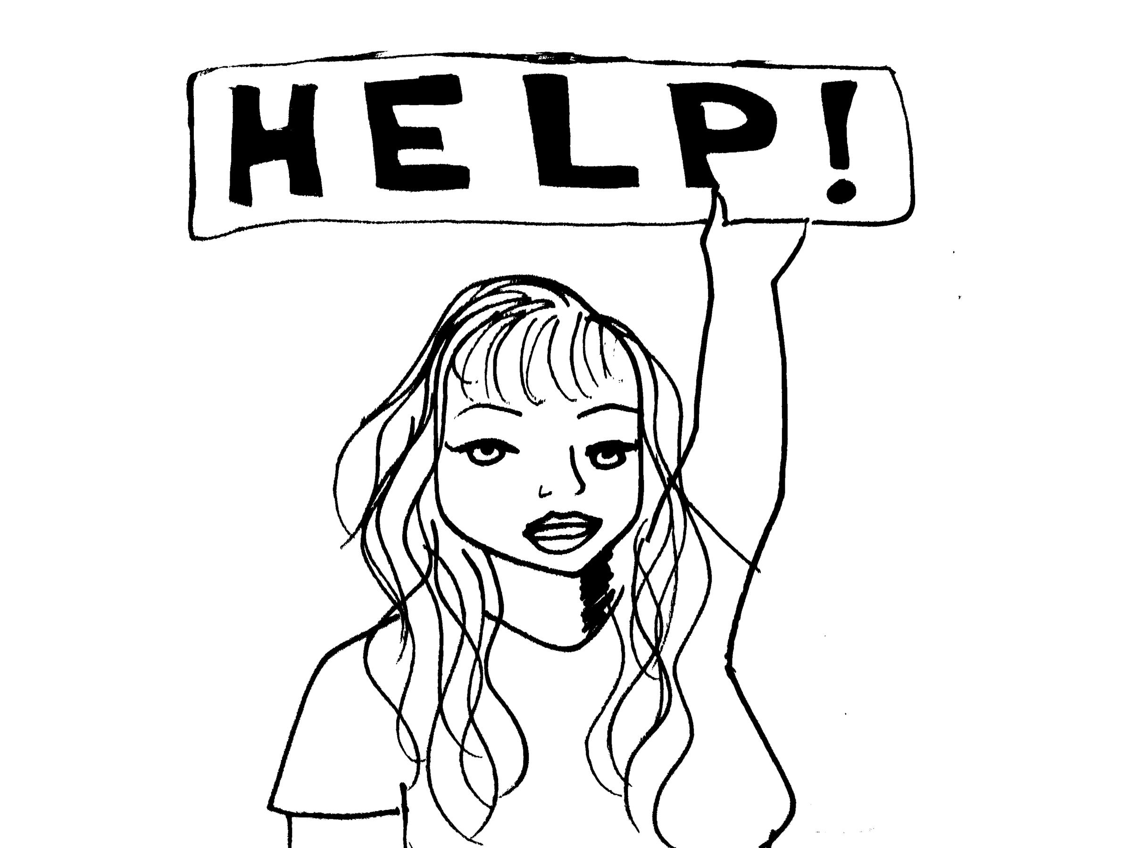
  - Confusion
  - Vomiting
  - Difficulty in Coordinating
  - Fainting

Learning How to Identify and Treat Heat Related Illnesses
Time: 15 mins
Materials: Butcher Paper, Markers, Computer

Heat Cramps
Common Symptoms: Heat cramps are muscular pains and spasms that usually occur in the legs or abdomen. Heat cramps are often an early sign that the body is having trouble with the heat.Get the person to a cooler place and have him or her rest in a comfortable position. Lightly stretch the affected muscle and gently massage the area.
First Response: Give an electrolyte-containing fluid, such as a commercial sports drink, fruit juice or milk. Water may also be given if none of previously mentioned are available. Do not give the person salt tablets. Always encourage folks to go to the hospital/clinic if any discomfort persists as this can also serve as a record keeping tactic should anything serious result from the illness.

Heat Exhaustion
Common Symptoms: Heat exhaustion is a more severe condition than heat cramps. Heat exhaustion often affects athletes, firefighters, construction workers and factory workers. It also affects those wearing heavy clothing in a hot, humid environment.Signs of heat exhaustion include cool, moist, pale, ashen or flushed skin; headache; nausea; dizziness; weakness; and exhaustion.
First Response: Move the person to a cooler environment with circulating air. Remove or loosen as much clothing as possible and apply cool, wet cloths or towels to the skin. Fanning or spraying the person with water also can help. If the person is conscious, give small amounts of a cool fluid such as a commercial sports drink or fruit juice to restore fluids and electrolytes. Milk or water may also be given. Give about 4 ounces of fluid every 15 minutes. Always encourage folks to go to the hospital/clinic if any discomfort persists as this can also serve as a record keeping tactic should anything serious result from the illness.
If the person’s condition does not improve or if he or she refuses water, has a change in consciousness, or vomits, call 9-1-1 or the local emergency number.

Heat Stroke
Common Symptoms: Heat stroke is a life-threatening condition that usually occurs by ignoring the signals of heat exhaustion. Heat stroke develops when the body systems are overwhelmed by heat and begin to stop functioning.Signs of heat stroke include extremely high body temperature, red skin which may be dry or moist; changes in consciousness; rapid, weak pulse; rapid, shallow breathing; confusion; vomiting; and seizures.
First Response: Heat stroke is life-threatening. Call 9-1-1 or the local emergency number immediately.
Rapidly cool the body by immersing the person up to the neck in cold water, if possible OR douse or spray the person with cold water.
Sponge the person with ice water-doused towels over the entire body, frequently rotating the cold, wet towels.
Cover the person with bags of ice.
If you are not able to measure and monitor the person’s temperature, apply rapid cooling methods for 20 minutes or until the person’s condition improves. Always encourage folks to go to the hospital/clinic if any discomfort persists as this can also serve as a record keeping tactic should anything serious result from the illness.

What is OSHA and Cal/OSHA?
Time: 20 mins
Materials: Butcher Paper, Markers, Computer

Instructor: Ask participants if they are familiar with the agencies in place to aid workers regarding health and safety violations. Wait for replies, then go over OSHA and CAL-OSHA information and differences. State disclaimer between federal and state agencies as some laws and regulations differ from state to state.
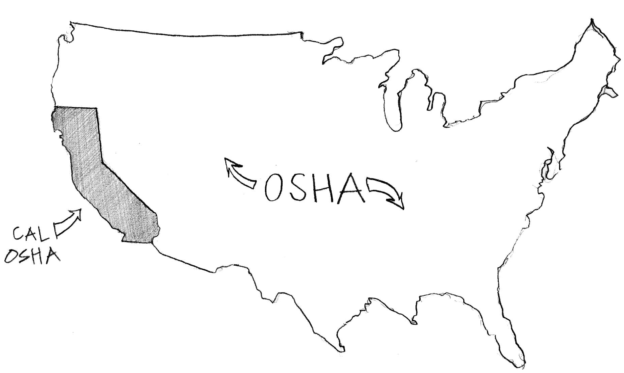

The Occupational Safety and Health Administration (OSHA) is an agency of the United States Department of Labor. Congress established the agency under the Occupational Safety and Health Act.

States are encouraged to develop and operate their own job safety and health programs. They must be as effective as the federal OSHA program. California’s OSHA-approved State Plan is also known as Cal/OSHA. In California, similar to the federal program, every employer has a legal obligation to provide and maintain a safe and healthful workplace for employees. CalOSHA also has specific rules and regulations that are unique to California.

Workers have a right to a safe workplace. The law requires employers to provide their employees with safe and healthful workplaces. The OSHA law also prohibits employers from retaliating against employees for exercising their rights under the law (including the right to raise a health and safety concern or report an injury).

Workers may file a complaint to have OSHA if they believe that their employer is not following OSHA standards or that there are serious hazards. Workers can file a complaint with OSHA by calling 1-800-321-OSHA (6742), online via e-Complaint Form, or by printing the complaint form (slide 9) and mailing or faxing it to the local OSHA area office, which can be found online at https://www.osha.gov/oshdir/ca.html or by calling the OSHA number previously mention. Complaints that are signed by a worker are more likely to result in an inspection, however; this is not always the case for Federal OSHA.

If you think your job is unsafe or if you have questions, contact OSHA at 1-800-321-OSHA (6742). Your contact will be kept confidential, to ensure this happens please make this explicit in the call or OSHA form.

In California there are certain protections enforced by CalOSHA, such as the Injury and Illness Prevention Plan which aim to protect workers against workplace hazards. Employers are still required to prevent hazardous exposure to high indoor temperatures under the California Injury and Illness Prevention Program standard (Title 8, Section 3203). Additional requirements apply to workplaces regarding mechanical ventilation (Title 8, Sections 5142-3), provision of drinking water (Title 8 CCR Section 3363), sanitary facilities (Title 8, Sections 3364-5), washing facilities (Title 8, Section 3366), and medical services and first aid (Title 8, Section 3400).

In California, there are a few worker organizations, including the Garment Worker Center, who are working with Cal/OSHA to make an indoor heat standard for indoor workers a reality. Workers and worker advocates introduced Senate Bill no. 1167, Mendoza. Employment safety: indoor workers: Heat Regulations, which was approved by Governor Brown in Sept 29, 2016. Although the language to this proposal is still being solidified (expected to be in full effect by 2019), the proposal itself was drafted from the existing outdoor worker heat illness prevention plan:

Heat Illness Prevention Plan
The employer must develop, put in writing, and implement effective procedures for complying with the requirements of T8 CCR 3395. The Heat Illness Prevention Plan includes the following:
- Procedures for providing sufficient water
- Procedures for providing access to shade
- High-heat procedures
- Emergency response procedures
- Acclimatization methods and procedures
The Heat Illness Prevention Plan must be written both in English and in the language understood by the majority of employees. It must be available to employees at the worksite, as well as to representatives of Cal/OSHA upon request. It may be integrated into the employer's Injury and Illness Prevention Program.
The relentless efforts of workers and worker advocates have made the indoor heat proposal a reality and although indoor heat regulation proposal itself is not finalized, workers can still contact OSHA should they feel that their working environments are unsafe.

Disclaimer:

This material was produced under grant number SH-29641-16-60-F6 SH5 from the Occupational Safety and Health Administration, U.S. Department of Labor. It does not necessarily reflect the views of policies of the U.S. Department of Labor, nor does mention of trade names, commercial products, or organizations imply endorsement by the U.S. Government.

Training materials developed with grant funds will be posted at:
http://www.osha.gov/dtle/library

Concluding Activity:
Time: 15 mins

Instructor: Let participants know that we are about to engage in a verbal activity which will put what they have learned to the test. Read the scenarios, ask the questions, and write down their answers. Activity: Verbal Worker Scenario
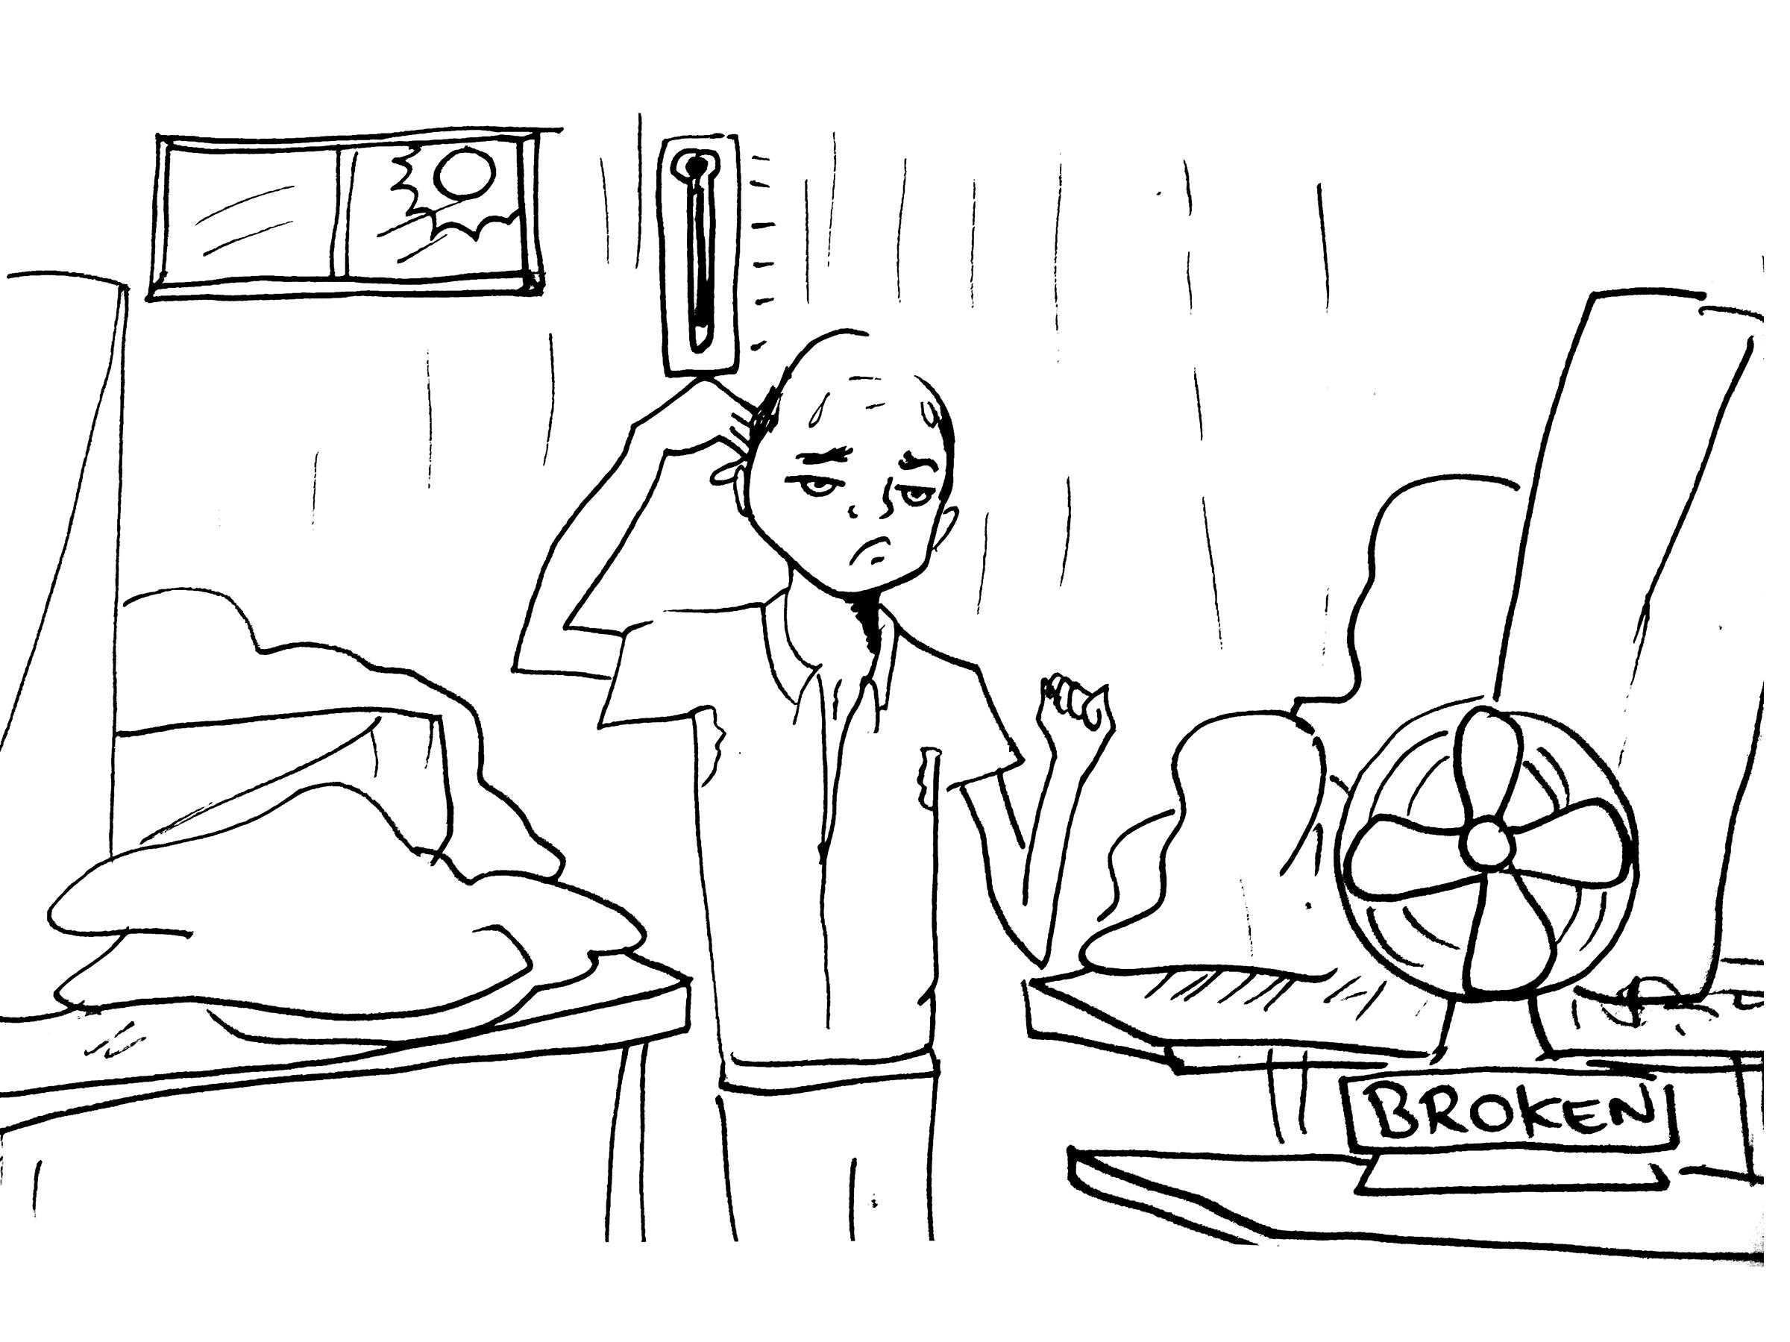
It is a hot day in the Los Angeles garment district with temperatures reaching 95 degrees fahrenheit, outside. Jose, a sewing operator, comes into work where he is surrounded by sewing machines (front, back, and on his sides) and piles of cloth around him. There is only one window and no fans in the factory. By the 2nd hour of his shift, Jose is drenched in sweat he starts to feel light headed and nauseous. He tells his co-worker, Jesse, that he is not feeling well. Jesse tells Jose to drink water attributing his symptoms to dehydration. Their boss does not provide water for the workers in the factory and Jose forgot to bring water with him. Jose goes to the bathroom to get some air and water. Upon returning to his work station, he feels his back begin to tense up. He started to get cramps on his left side of his back. He gets back up, fatigued, and tell his boss he is not feeling well. His boss tells him to stop complaining and go back to work. A blurry visioned Jose starts making his way back to his seat when he collapses.

Questions to be asked:

- What symptoms should Jose and Jesse paid attention to or taken special precautions for?
- What notable violations did you notice?
- What should Jose have done? What should the boss have done?
- What are some of the measures that could have been taken to prevent this?
- What would you have done different?

Activity: Verbal Worker Scenario
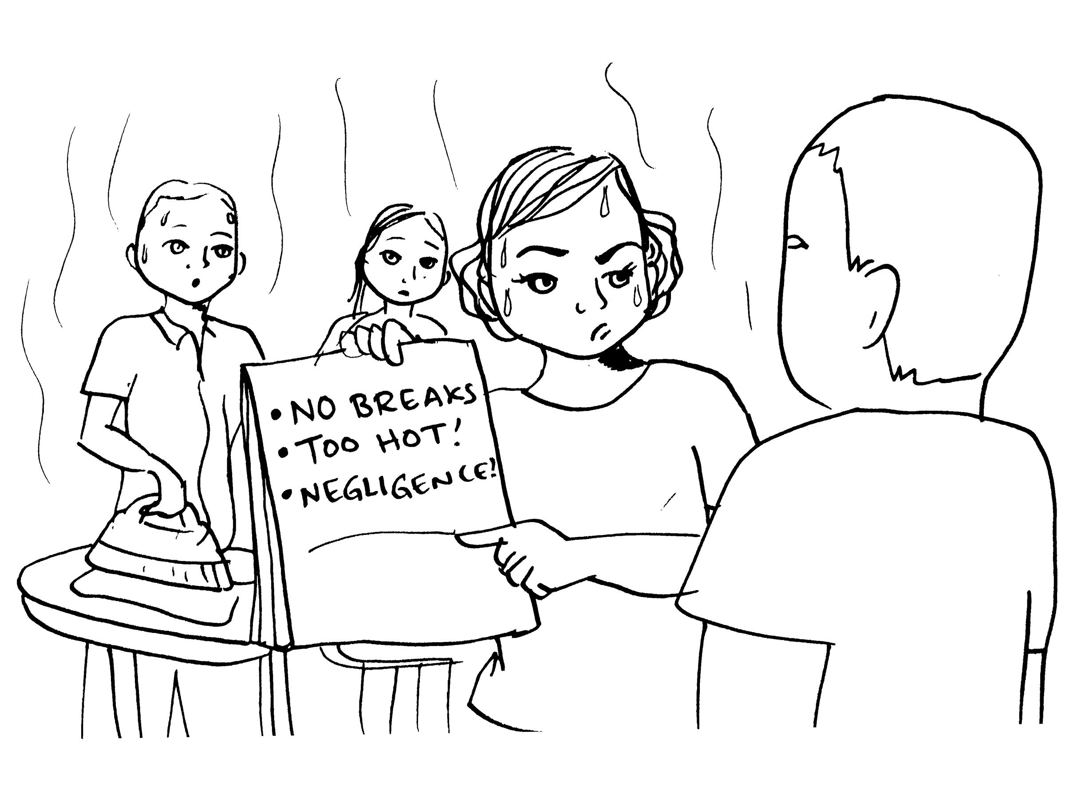
Vicky is a presser at a garment factory in Downtown Los Angeles. It’s the third consecutive day that temperatures have been above 100 degrees fahrenheit. Vicky works with 5 other pressers at her work station where there is no ventilation. While Vicky’s boss provides water for them, he does not give them the breaks needed for the workers to cool down. Most of her co-workers continue to say that it is too hot to be pressing clothes as this adds more heat to the already scorching weather. Vicky takes notes of the temperature outside and the fact that her boss is not providing the adequate breaks from them to cool down, then goes and tells her boss that she and co workers are not feeling well. The boss dismisses Vicky’s concerns and denies the acclimatization breaks and instructs Vicky to go back to work. Vicky takes note of this too. She then tells her co workers who are fatigued and dizzy to put their health first and if need be take a break as the temperatures have been unsafe to work under.

Questions to be asked:

- Where can Vicky go to seek help?
- What symptoms should Vicky and her co workers pay attention to or take special precautions for?
- What notable violations did you notice?
- Did Vicky have any right to tell her co workers to put their health first? What should the boss have done?
- What are some of the measures that could have been taken to prevent this?
- What would you have done different?

