Dangers of Inadequate Ventilation Inside Garment Factories

Welcome & Food
Time: 15 mins

Introduction
Time: 10 mins

Instructor: Welcome everyone and thank the participants for attending. Introduce yourself and have everyone else introduce themselves as well. Introduce the Garment Worker Center (mission and vision). Go over the agenda with the participants to let them know the topics that will be covered, Dangers of inadequate ventilation inside Garment Factories.

Time: 15 mins
Material: Butcher Paper, Markers, Projector, Screen Projector, Computer
Activity: Begin with a breathing exercise. Instruct the participants to stand up, close their eyes, and ask them to inhale and exhale 6 times.

Ask participants about how they feel after the exercise. Wait for verbal answers. Write them down on butcher paper.

Share: Unless we are doing a strenuous activity, most of us often do not pay much attention to our breathing habits as they come as first nature. To start the dialogue here are some questions to ask participants: Why is breathing important? Why is breathing clean air important? Why is ventilation important?

Ask participants if it is common for garment factories to have dust pollution at their working site. Share the findings of the health and safety survey with the participants (show first ppt slide): 72% of garment workers reported that there was a lot of dust in their factories. Ask: Is this similar to the reality you experience at work? Ask and wait for answers from folks. Write down responses on butcher paper.
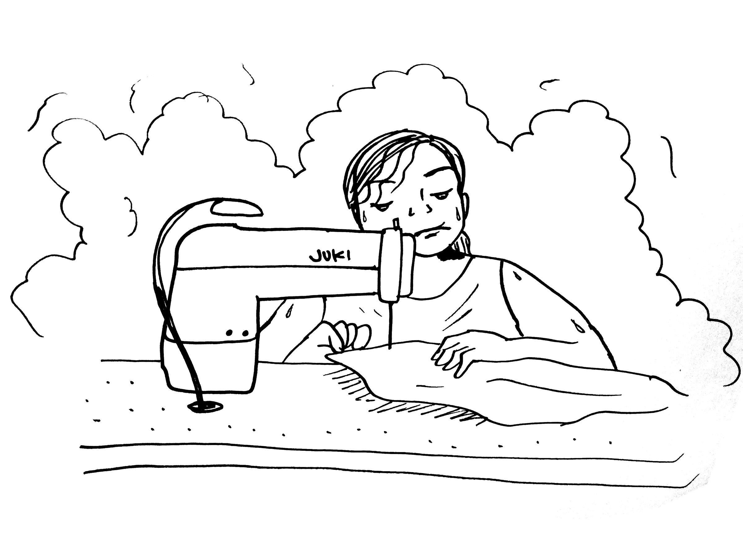
Garment Ventilation Problems
Time: 30 mins
Material: Butcher Paper and Markers

When the Garment Worker Center surveyed workers regarding working conditions at their respective jobs, many of them shared that both ventilation and dust were significant problems. Workers reported that in most cases open windows were the only source of ventilation for them. Very few reported having proper fans at work, many reported having to bring small personal fans to be able to have some sort of ventilation. A small portion reported having adequate ventilation systems. The dangers of dust accumulation is exacerbated by the lack of proper ventilation in the factories.

Ask participants: How is the ventilation at your respective jobs? What do you typically use at work for ventilation? What do you think an adequate ventilation system should have or look like? Ask and wait for answers from folks. Write down responses on butcher paper.

Share:

Local Exhaust Ventilation (LEV) Systems

A typical local exhaust ventilation system is composed of five parts:

1. Fans

2. Hoods

3. Ducts

4. Air cleaners

5. Stacks

Local exhaust ventilation is designed to capture an emitted contaminant at or near its source, before the contaminant has a chance to disperse into the workplace air. The system needs to be thoroughly examined regularly to demonstrate it is performing to design. It is recommended that the system be checked at least every 14 months, or more frequently if the manufacturer recommends it. Also, simple routine checks can be carried out when the system is in use.

Severe problems may arise without a proper ventilation system. What are some of the causes of irritations or other problems due to lack of ventilation? Ask and wait for answers from folks. Write down responses on butcher paper.

Share:
- Indoor environment: inadequate temperature, humidity, poor air circulation, improper or inadequately maintained heating and ventilation systems.
- Indoor air contaminants: chemicals, dusts, molds or fungi, bacteria, gases, vapours, odors.
- Insufficient outdoor air intake.
- Contamination by construction materials, glues, fiberglass, particle boards, paints, chemicals, etc.
- Increase in number of workers at the factories and time spent indoors.

Instructor: Ask participants, What are some of the ventilation problems they face at their workplace?

If participants have a hard time trying to come up with some examples, give examples of how the lack of proper ventilation might affect the body:

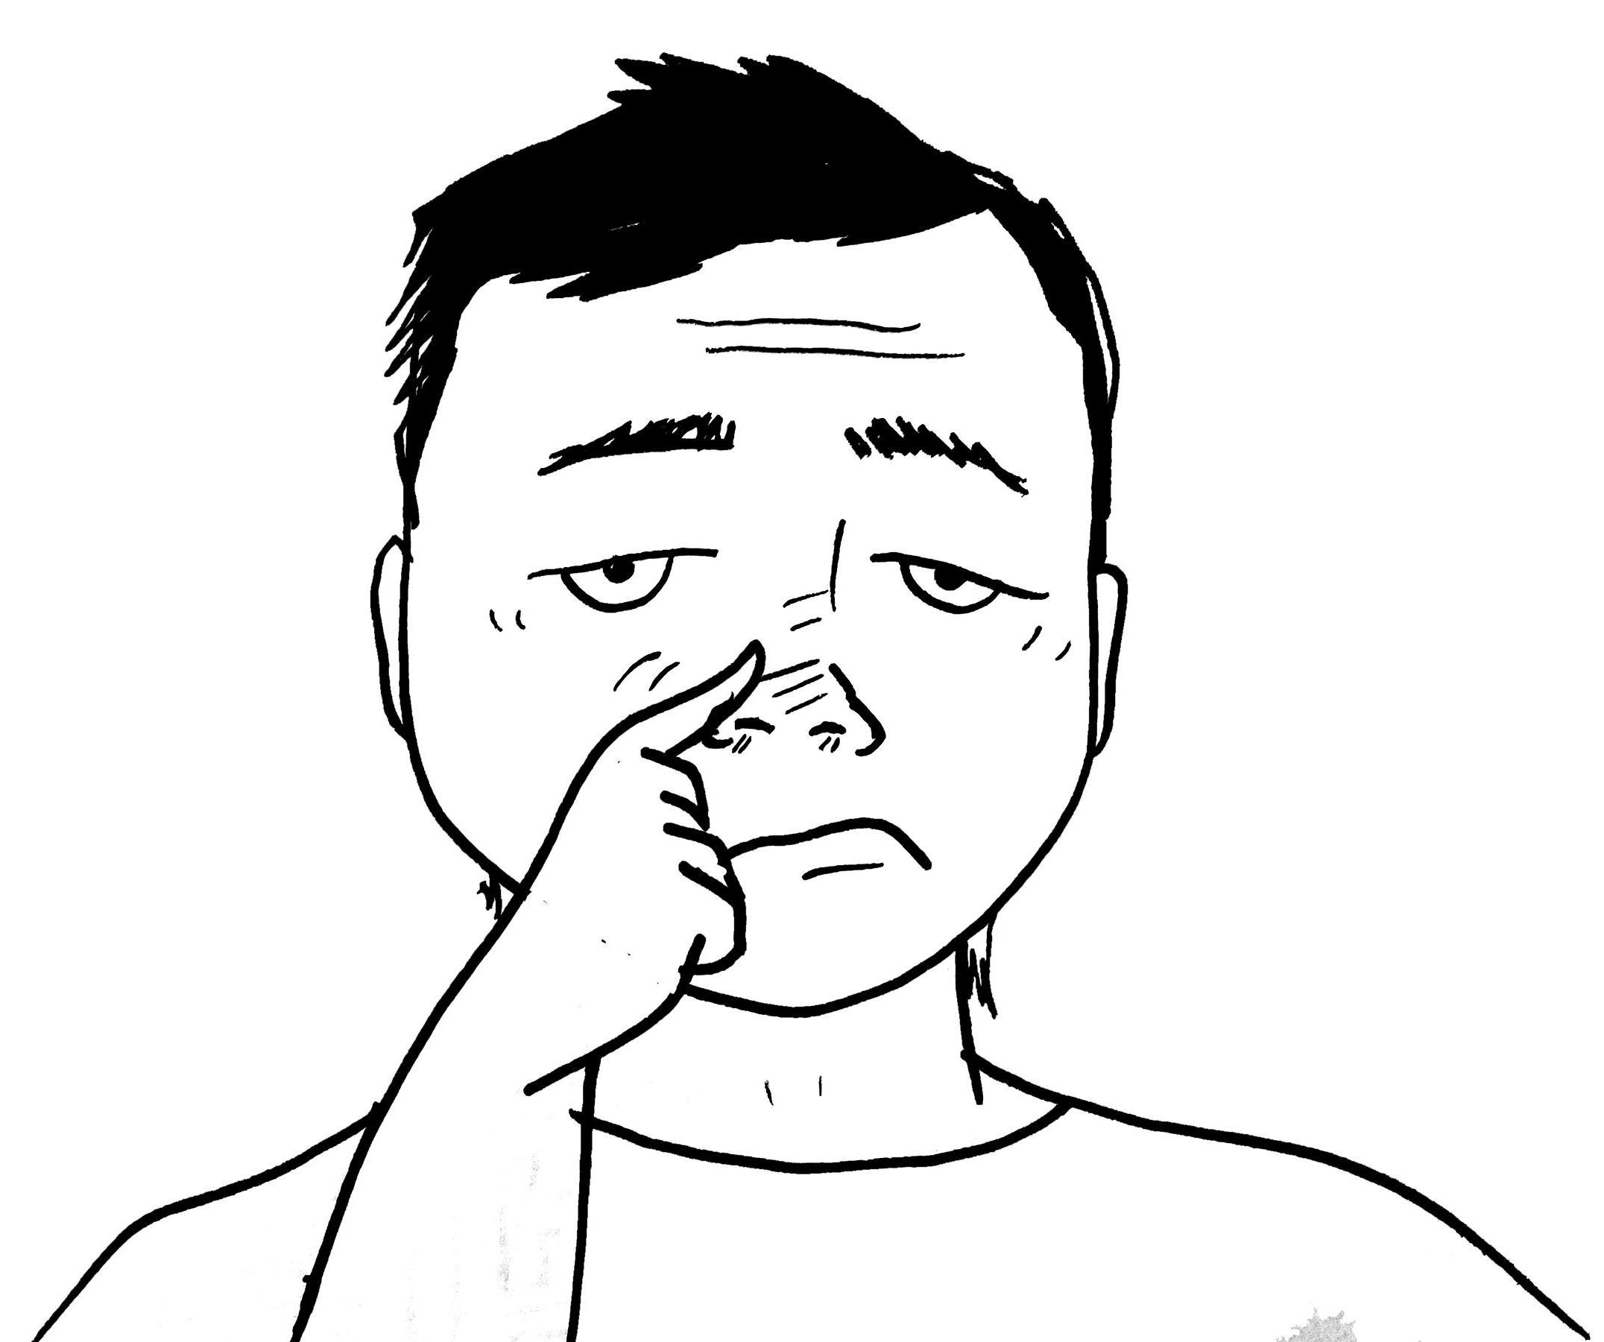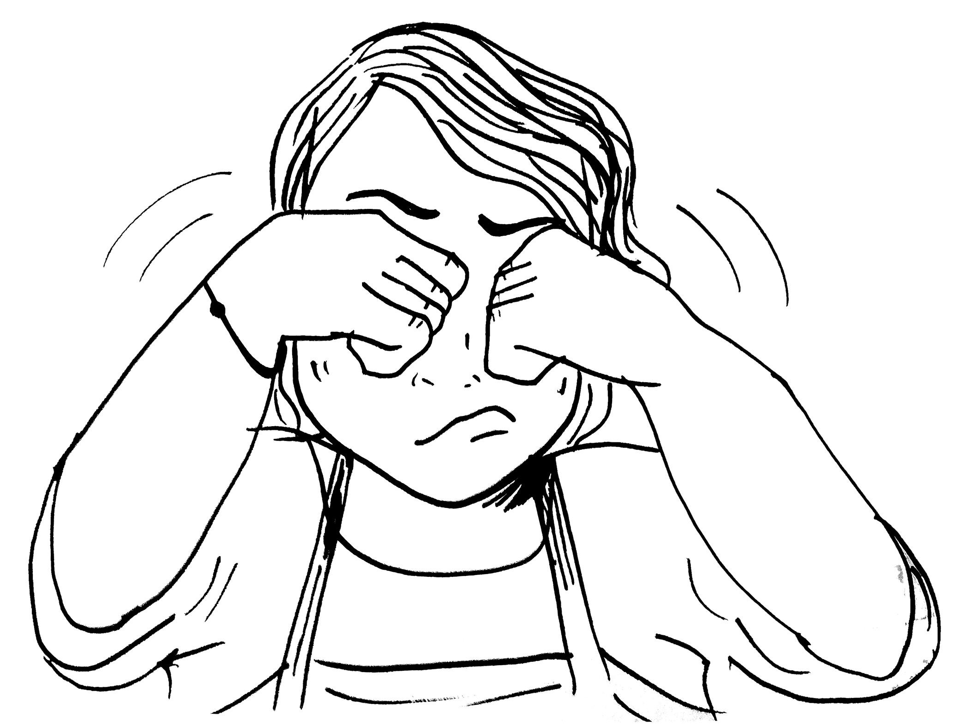

    - Ask: Have you ever experienced any of the following during or after work:
      - Feeling like you are constantly out of breath
      - Irritation in eyes, nose, and/or throat
      - Nausea
      - Fatigue
      - Allergies/ Sinus Congestion
      - Coughing and sneezing
      - Dizziness
    - Share: You might not feel these symptoms right away. You might feel these when you get out of the factory, when you get home, and as you are away from the immediate dangers.
    - Share: As with any other occupational illness, not all people are affected with the same symptoms or to the same extent. Some people may be more sensitive than others. Some people may be exposed to more contaminants in the building than others and they may experience symptoms earlier than other people. As air quality deteriorates and/or the length of exposure increases, more people tend to be affected and the symptoms tend to be more serious.

Share: Inadequate ventilation can lead to short term or long term effects on our bodies. Define the terms “acute” and “chronic” in reference to the symptoms.
- Acute: Abrupt, sharp, and brief. Often connotes an illness that is of short duration, rapidly progressive, and in need of urgent care.
- Chronic: Lasting a long time. A chronic condition is one that lasts 3 months or more.
  - *Be sure to state that both definitions are in reference to medicine.
  - *If participants should ask, be sure to clarify that neither of the above definitions are mutually exclusive.

Instructor: Tell participants that we will be focusing on the acute effects of ventilation for the purposes of this training.

Instructor: Go over examples of common indoor air contaminants and their main sources:

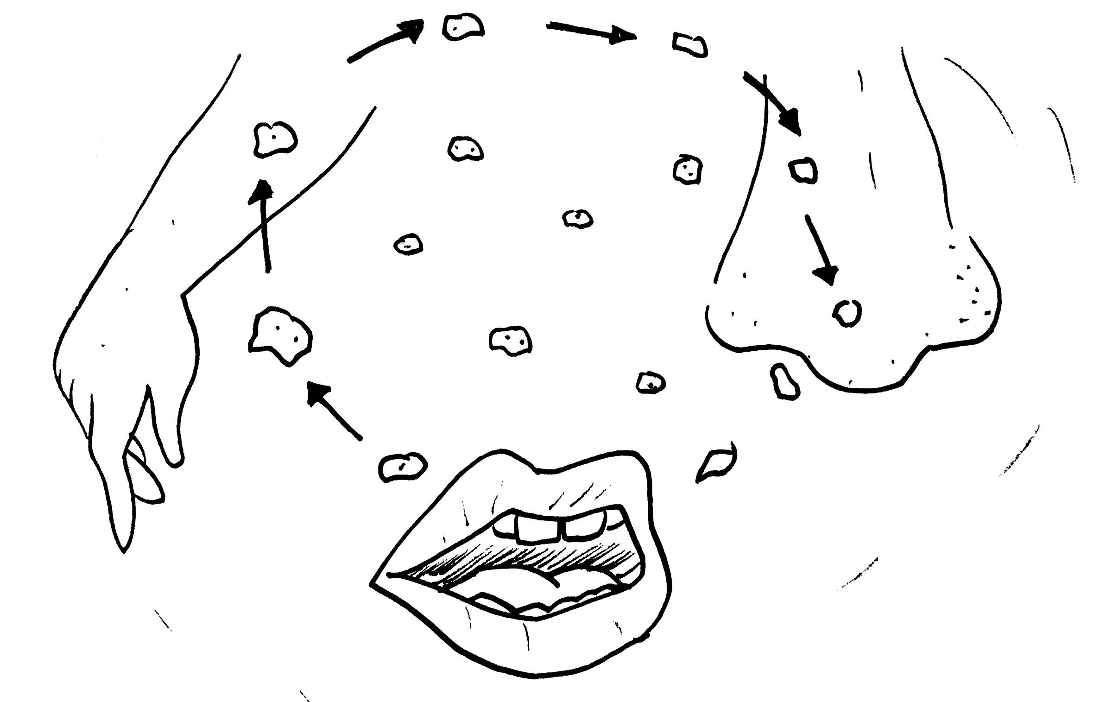
Slide 3: Carbon dioxide (CO2)
- Sources: tobacco smoke, perfume, body odors – from building occupants.
  - Acute health effects: Irritation to the eyes, nose, and throat. It may affect vision by inducing proptosis, mydriasis, yellowed vision, and transient blindness. Retinal ganglion cells have also been noted to be damaged.

Slide 4: Dust, fiberglass, asbestos, gases, including formaldehyde – from building materials.
  - Sources: Fibrous glass and mineral wool. Off-gassing from urea formaldehyde foam insulation, plywood, particle board, and paneling; carpeting and fabric; glues and adhesives; and combustion products including tobacco smoke.
    - Acute health effects: Irritation to the eyes, skin and lungs; dermatitis. Hypersensitive or allergic reactions; skin rashes; eye, respiratory and mucous membrane irritation; odor annoyance.
Slide 5: Nitrogen Oxides
  - Sources: Combustion products from gas furnaces and appliances; tobacco smoke, welding, and gas- and diesel-engine exhausts.
    - Acute health effects: Eye, respiratory and mucous membrane irritation.

Slide 6: Microorganisms and Other Biological Contaminants (Microbial). Includes viruses, fungi, mold, bacteria, nematodes, amoeba, pollen, dander, and mites.
  - Sources: Air handling system condensation, cooling towers, water damaged materials, high humidity indoor areas, damp organic material and porous wet surfaces, humidifiers, hot water systems, outdoor excavations, plants, animal feces, animals and insects, food and food products.
    - Acute health effects: Allergic reactions such as hypersensitivity diseases (hypersensitivity pneumonitis, humidifier fever, allergic rhinitis, etc.) and infections such as legionellosis are seen. Symptoms include chills, fever, muscle ache, chest tightness, headache, cough, sore throat, diarrhea, and nausea.

Instructor: Briefly summarize what you’ve covered with the workers and let them know that we are going to put what we’ve learned into action at the end of the training.

Prevention and Protection
Time: 30 mins
Material: Butcher Paper, Markers, Projector, Screen Projector, Computer

Instructor: Ask participants how they think they can protect themselves against some of the contaminant previously mentioned. Write down the replies on the butcher paper.
Share: Workers might report symptoms that they don’t automatically link to proper ventilation because these symptoms are often times similar to those of the common cold or flu. Unfortunately finding the source or cause can often be difficult. The steps taken to better our health through proper ventilation may vary from situation to situation but can include using tools such as:

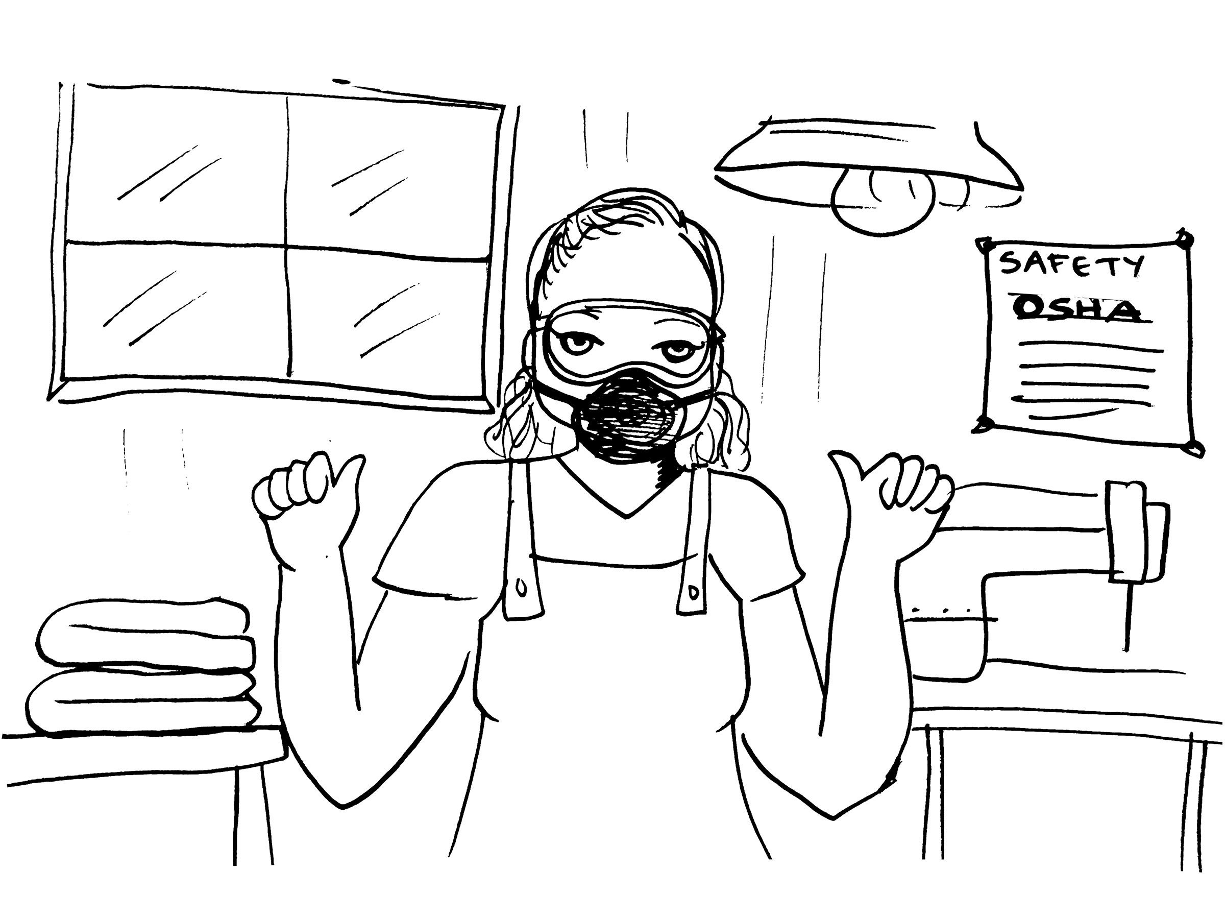
- Respirators- protective device that covers the nose and mouth or the entire face or head to guard the wearer against hazardous atmospheres. Respirators may be:
- Tight-fitting - that is, half masks, which cover the mouth and nose and full facepieces that cover the face from the hairline to below the chin; or
- Loose-fitting, such as hoods or helmets that cover the head completely.
- In addition, there are two major classes of respirators:
- Air-purifying, which remove contaminants from the air; and
- Atmosphere-supplying, which provide clean, breathable air from an uncontaminated source. As a general rule, atmosphere-supplying respirators are used for more hazardous exposures.

Why do employees need respirators?

When employees must work in environments with insufficient oxygen or where harmful dusts, fogs, smokes, mists, fumes, gases, vapors, or sprays are present, they need respirators. These health hazards may cause cancer, lung impairment, other diseases, or death.

OSHA's respirator standard requires employers to establish and maintain an effective respiratory protection program when employees must wear respirators to protect against workplace hazards. Different hazards require different respirators, and employees are responsible for wearing the appropriate respirator and complying with the respiratory protection program.

The primary objective of the respiratory protection program is to prevent exposure to air contaminated with harmful dusts, fogs, fumes, mists, gases, smokes, vapors, or sprays, and thus to prevent occupational illness.

A program administrator must be responsible for the program. This person must know enough about respirators to supervise the program properly. Any respirator program should stress thorough training of all respirator users. Employees must be aware that a respirator does not eliminate the hazard. If the respirator fails, the user will be overexposed to dangerous substances. To reduce the possibility of failure, the respirator must fit properly and be maintained in a clean and serviceable condition. Employers and employees must understand the respirator's purpose and limitations. Users must not alter or remove the respirator even for a short time, even if it is uncomfortable.

An effective respirator program must cover the following factors:
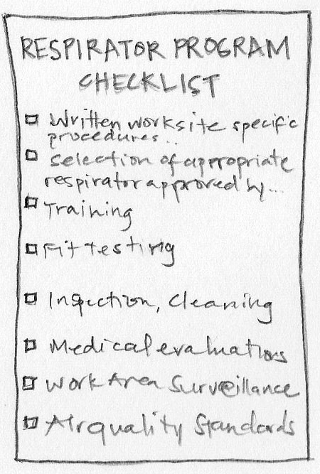

- Written worksite specific procedures;
- Program evaluation;
- Selection of an appropriate respirator approved by the National Institute for Occupational Safety and Health (NIOSH);
- Training;
- Fit testing;
- Inspection, cleaning, maintenance, and storage;
- Medical evaluations;
- Work area surveillance; and
- Air quality standards.

Who needs to be trained?

Whenever the OSHA standards or employers require respirator use, there must be a complete respiratory protection program. Employers must have written operating procedures to ensure that employees use the respirators safely and properly. Users must be familiar with these procedures and with the respirators available and their limitations.

Training is essential for correct respirator use. Employers must teach supervisors and workers how to properly select, use, and maintain respirators. All employees required to use respiratory protective equipment must receive instruction in the proper use of the equipment and its limitations. Employers should develop training programs based on the employee's education level and language background.

Training must be comprehensive enough for the employee to demonstrate a knowledge of the limitations and capabilities of the respirator, why the respirator is necessary, and how improper fit, usage, or maintenance can compromise the respirator.

Employers are required to follow the General Duty Clause of the OSHAct, which requires them to provide workers with a safe workplace that does not have any known hazards that cause or are likely to cause death or serious injury. The OSHAct also requires employers to obey occupational safety and health standards created under it. Employers should be reasonably aware of the possible sources of poor air quality, and they should have the resources necessary to recognize and control workplace hazards. It is also their responsibility to inform employees of the immediate dangers that are present.Specific state and local regulations may apply.

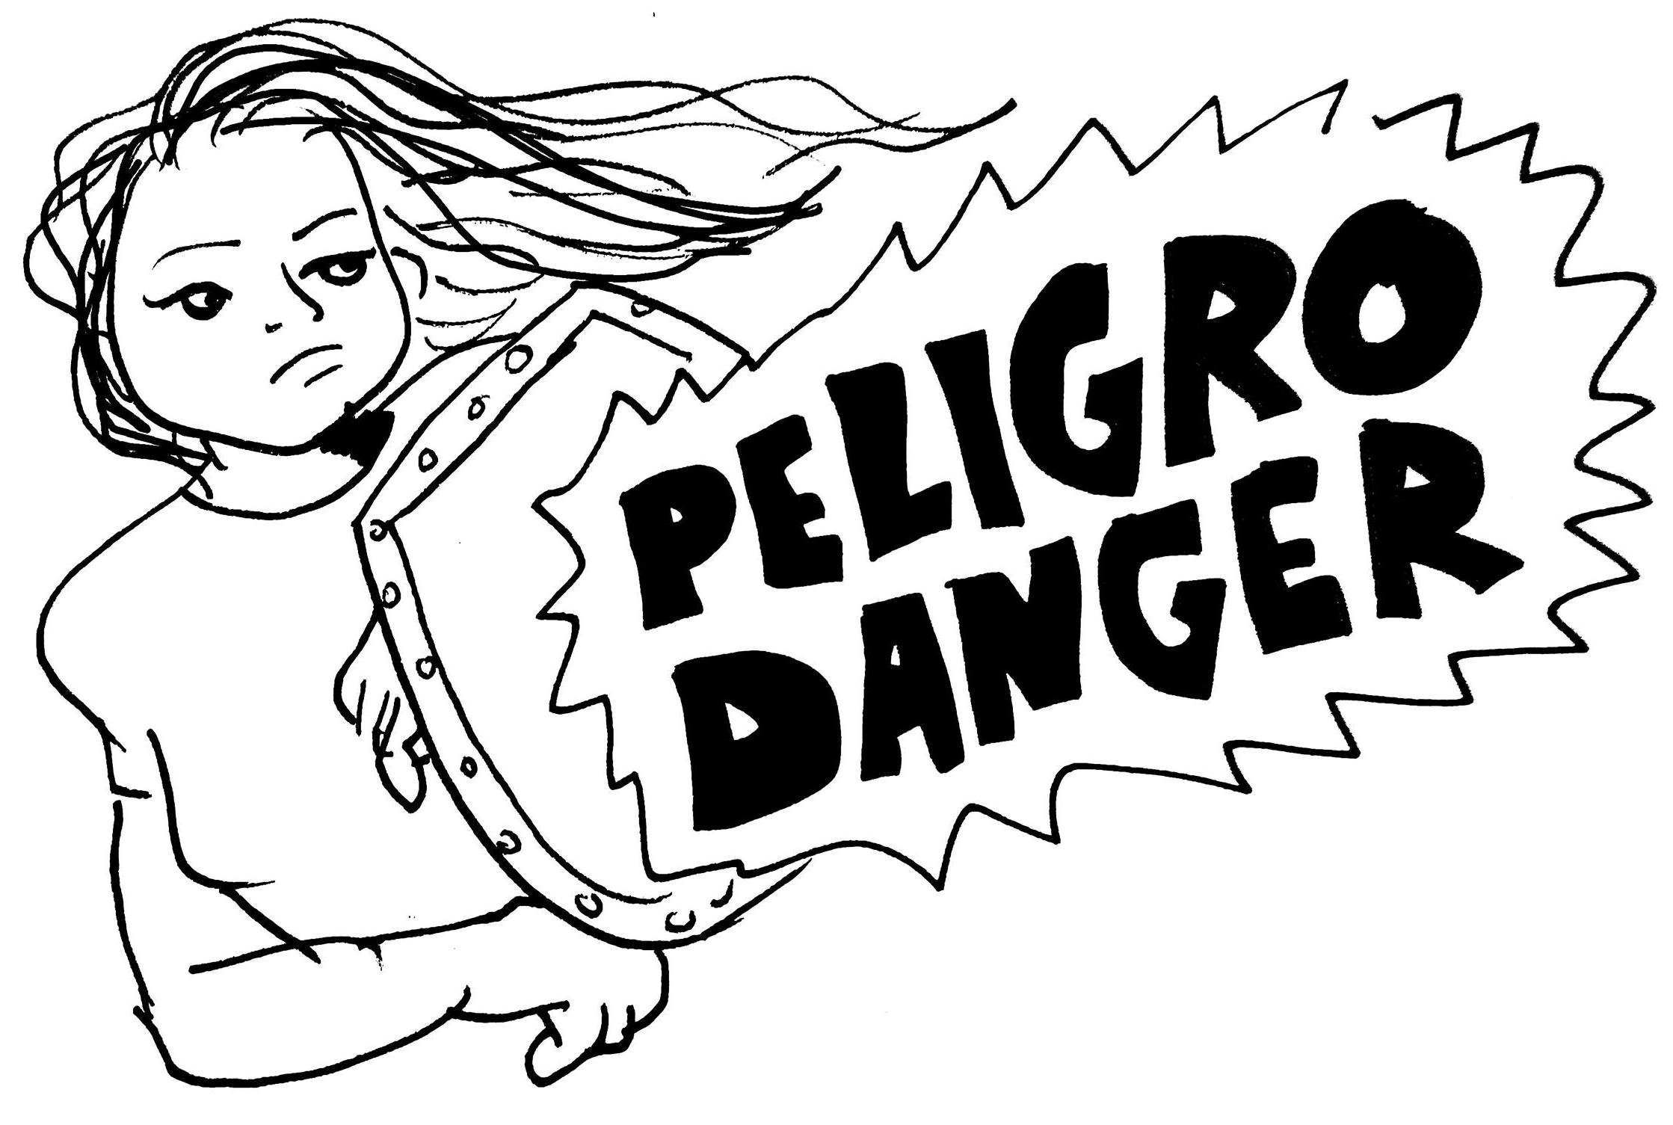
- 1st level prevention and protection:
  - Workers can request that windows and fans be in operating conditions (on or open) at all times while they are working to better promote air circulation.
  - Workers can wear personal protective equipment such as mask and goggles to protect themselves from the contaminants in the air.
  - Workers can and should begin to document everything that is negated to them including any in acts by management or bosses that they feel violated their rights as workers. This doesn’t necessarily guarantee that everything they document will prove to be a violation but this can help once a case is finally filed.
  - Provide worker training. Workers need to be trained in the purpose and importance of proper ventilation.

- 2nd level prevention and protection:
  - Urge the employer to investigate the ventilation system to make sure it is operating properly for example the right mix of fresh air, open windows, and filtration systems are working properly.
  - Establish a program of periodic ventilation inspection daily, weekly, and/or monthly.
  - Build a health and safety committee with workers to be able to lend support in case of inadequate ventilation.
    - This committee can then help establish a preventive maintenance program which would urge employer to check their ventilation systems regularly.
  - Conduct a survey to help pinpoint work sources and causes.
  - Look for possible causes like source of a chemical, renovations, mold, etc. ( show our survey to folks)

- 3rd level prevention and protection:
  - Workers have the right to step out of any environment where they feel their safety is at risk. If the workers are experiencing symptoms due to lack of proper ventilation, workers should notify their boss, management, and their co-workers that they will be leaving the premises.
  - If management or employer refuses to listen to the concerns of the workers, the workers then can gather the documents and evidence of negligence to file a claim with OSHA/Cal-OSHA

What is OSHA and Cal/OSHA?
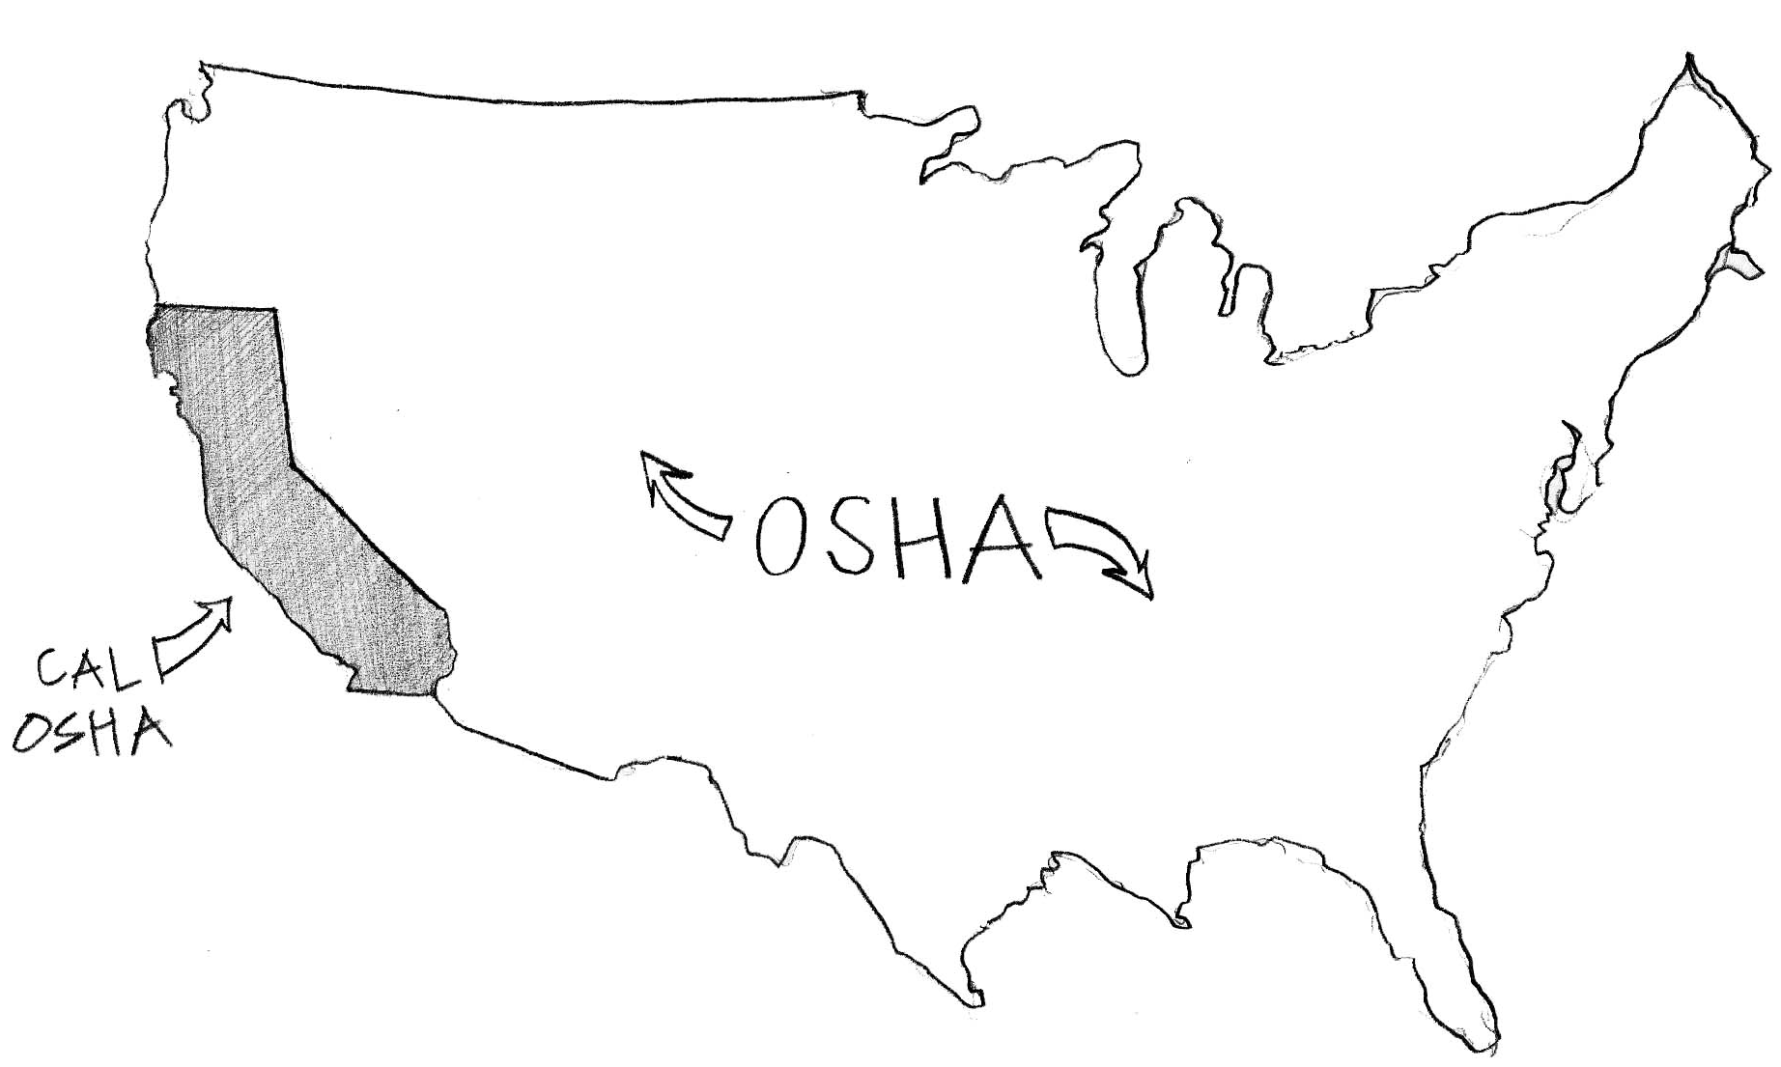
Instructor: Ask participants if they are familiar with the agencies in place to aid workers regarding health and safety violations. Wait for replies, then go over OSHA and CAL-OSHA information and differences. State disclaimer between federal and state agencies as some laws and regulations differ from state to state.

The Occupational Safety and Health Administration (OSHA) is an agency of the United States Department of Labor. Congress established the agency under the Occupational Safety and Health Act. This agency is in place to aid workers on a federal level.

In California we also have a version of OSHA which focuses more on California specific rules and regulations. Here, every employer has a legal obligation to provide and maintain a safe and healthful workplace for employees, according to the California Occupational Safety and Health Act of 1973.

Workers have a right to a safe workplace. The law requires employers to provide their employees with safe and healthful workplaces. The OSHA law also prohibits employers from retaliating against employees for exercising their rights under the law (including the right to raise a health and safety concern or report an injury).

Workers may file a complaint to have OSHA inspect their workplace if they believe that their employer is not following OSHA standards or that there are serious hazards. Workers can file a complaint with OSHA by calling 1-800-321-OSHA (6742), online via eComplaint Form, or by printing the complaint form (slide 9) and mailing or faxing it to the local OSHA area office. Complaints that are signed by a worker are more likely to result in an inspection.

If you think your job is unsafe or if you have questions, contact OSHA at 1-800-321-OSHA (6742). Your contact will be kept confidential.

Disclaimer:

This material was produced under grant number SH-29641-16-60-F6 SH5 from the Occupational Safety and Health Administration, U.S. Department of Labor. It does not necessarily reflect the views of policies of the U.S. Department of Labor, nor does mention of trade names, commercial products, or organizations imply endorsement by the U.S. Government.

Training materials developed with grant funds will be posted at:
http://www.osha.gov/dtle/library

Concluding Activity:
Time: 15 mins

Instructor: Let participants know that we are about to engage in a verbal activity which will put what they have learned to the test. Read the scenarios, ask the questions, and write down their answers.

Activity: Verbal Worker Scenario

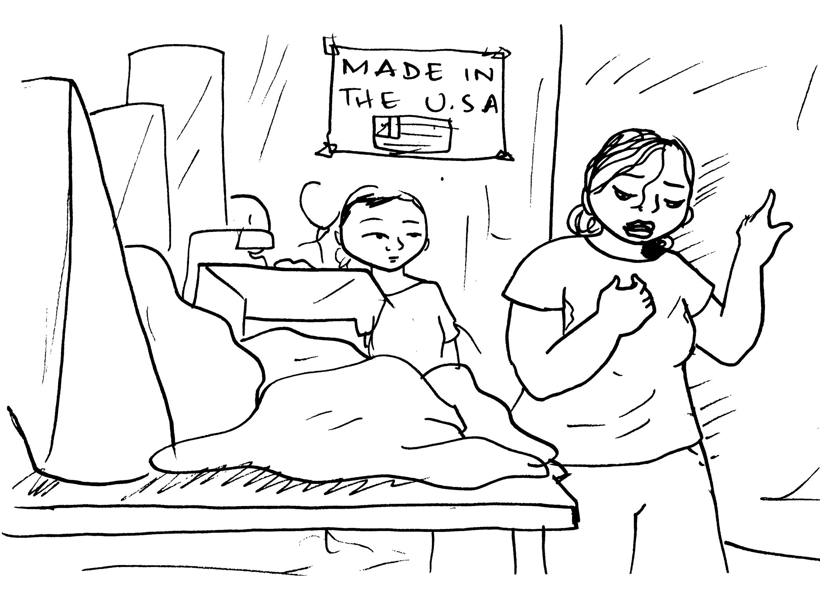
Lupita was trimming the string off of the bundles of clothing she was assigned on a very hot date during the summer. Lupita kept complaining that she felt as though she couldn't breathe and also had a pestering cough. The factory had about 30 garment workers present, no windows, nor fans were in the factory. After a few hours went by, Lupita couldn’t take it anymore and started to make her way outside of the factory, when she collapsed.

Questions to be asked:

- What was the error?
- What should she/boss have done?
- What are some of the measures that could have been taken to prevent this?
  - Low level/ High level

Activity: Verbal Worker Scenario

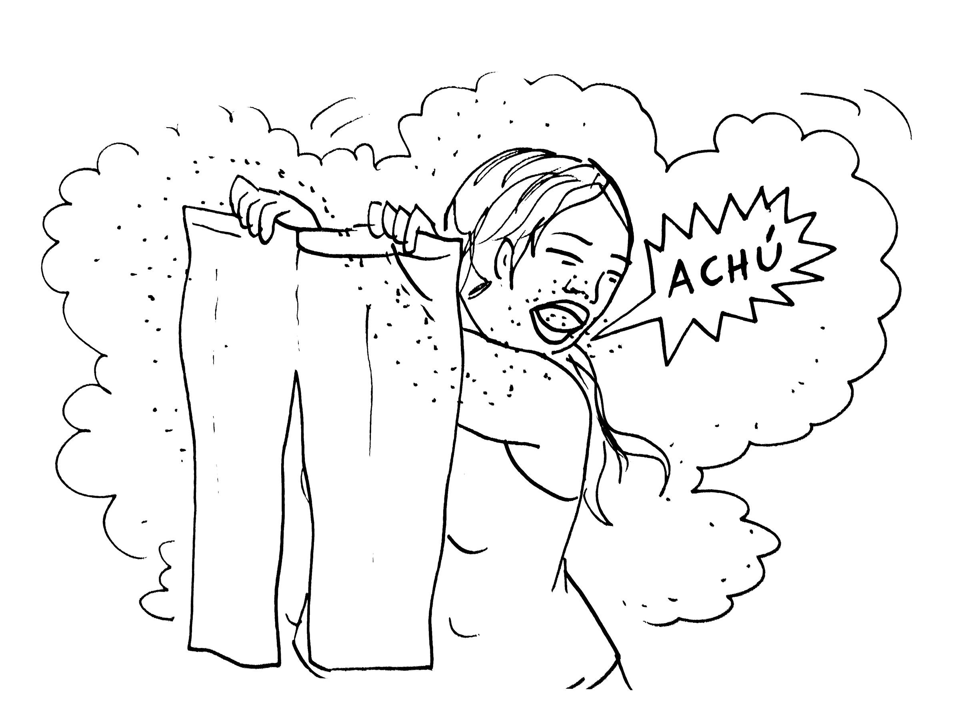

Reyna is a sewing operator making jeans at a garment shop in Los Angeles. As she was sewing dark denim fabric, she notices that her eyes, throat, and nose feel very irritated after a long day of working. She dismisses this as signs of the common flu and continues to work for the next few days. She finally decides to go to the clinic, where the Dr. tells her that she did not have the flu. In fact it was the fabric that she was working with that had caused most of the irritation to her eyes, throat and nose. As it turns out, Reyna is allergic to the the fabric and chemicals that the jeans are made out of. This has caused permanent damage to Reyna’s nose and throat.

Questions to be asked:

- What was the error?
- What should she/boss have done?
- What are some of the measures that could have been taken to prevent this?
  - Low level/ High level

